CALL for participation, in french = https://anr.fr/en/call-for-proposals-details/call/b0a01f77d9ba373ccb4215c9a487d64d/

Project acronym | ICoB
Project title | International Center of Bioacoustics [ ICoB ]
Titre du projet en français | Centre international BioAcoustique [ CIBA ]
Keywords / mots clés  (min 5 – max 10) | Acoustique, Bioacoustique, Anthropophonie, Biophonie, Interpréter, Modéliser, Prévenir, IA, microélectronique, Arithmétique optimisée, Basse consommation, Apprentissage de représentation supervisé semi / non supervisé, IA embarquée, Inférence, Interaction, Adaptation, Cybernétique, Biodiversité, Communication animale, Legislation
Responsables du projet / Project managers | Last Name, First name, Position, Organisation / Nom, Prénom, Statut, Organisation
Responsables du projet / Project managers | Hervé Glotin, Valentin Gies, Frédéric Schneider, Nicolas Mathevon, Gianni Pavan
Responsables du projet / Project managers | e-mail address / Courriel = les pilotes sur les 4 laboratoires = | Phone number / Téléphone
Responsables du projet / Project managers | herve.glotin@univ-tln.fr,  frederic.schneider@univ-tln.fr,  gies@univ-tln.fr  gianni.pavan@unipv.it | 0494215442  0628357685  +39 0382 987874

¹ Dans le cas où le projet est coordonné par deux responsables, remplir un encadré par responsable

Leading institution | Université de Toulon, EPST
Partner institution(s) involved in the project  / Institution(s) partenaire(s) impliqué(es) | Etatique : PNPC, PELAGOS, AGOA, OFB, Ministère de la Mer, MTES, DGA, CIRAD, PREMAR, IFREMER, NTU, Pavia Univ, Genova Univ, UNICE, Univ Victoria BC, Univ San Diego USA, Univ Halifax CA, Univ Tokyo (convention), Univ Montpellier, SHOM, MNHN Toulon, Marie de La Seyne, Mairie de St Cyr, Pole SCS, Pole MER, Univ Saint-Etienne  Laboratoires : COSMER, IMATH, CERC, IM2NP, LIS, et LMA, LAMFA, GEOAZUR, CIBRA, LAMLA, GEOAZUR, CPPM, IN2P3, MARBEC, ENES/CRNL…
Durée du projet entre 72 mois et 120 mois | 120 mois
Requested funding / Aide demandée (minimum 5M€) | 3 000 k€ | Full cost / Coût complet | 7 725 + 3 000 K€
Le cas échéant : Listes des projets PIA auxquels ce projet est éventuellement lié (notamment EUR, universités européennes, Equipex, Labex, Institut convergence, IDEFI, etc.) | PIA3 TERRA FORMA 2020-2028: Glotin est au Copil pour l’IA  PIA3 PsioBiom 202-2028: Glotin est au Copil pour l’IA  (+ Chaire IA ADSIL, FEDER MARITIMO GIAS, ANR SMILES, ANR JC IA, Mundus MIR, master ROC, DID…  ANR SYLVANIA, ANR ULPCOCHLEA, ANR SEAWHOLE, …
Ce projet s’inscrit-il dans le cadre d’une Initiative d’excellence labellisée IdEx ou ISITE ? | Ce projet s’inscrit dans le cadre d’une des 50 Chaires IA et d’autres projets stratégiques, 2 PIA3, plusieurs ANRs…
List of partner institutions / Liste des institutions partenaires
Renseigner une ligne par institution partenaire, ajouter autant de lignes que nécessaire.
Name of the research organisations /  Nom des organismes de recherche | Etatique : PNPC, PELAGOS, AGOA, OFB, Ministère de la Mer, MTES, DGA, CIRAD, PREMAR, ACCOBAMS, SHOM, MNHN, ministère du transport maritime du Canada. Laboratoires : COSMER, IMATH, CERC, IM2NP, LIS, et LMA, LAMFA, GEOAZUR, CIBRA, LAMLA, GEOAZUR, CPPM, IN2P3, MARBEC.
Name of the institutions of higher education and research / Nom des établissements d’enseignement supérieur et de recherche | UTLN, MNHN, NTU, Pavia Univ, Genova Univ, UNICE, Univ Saint-Etienne, Univ Victoria BC, Univ San Diego USA, Univ Halifax CA, Univ Tokyo (convention), Univ Montpellier. Formations : Mundus MIR Norvège, Portugal, Espagne, et UTLN. Masters ROC (un parcours de Vista) UTLN, DID UTLN, Master IAAA AMU / LIS / Centrale Marseille, Master MER composante pression anthropique UTLN… Licence Math-Informatique UTLN, IUT G2I UTLN, Licence Biologie UTLN, licence Physique UTLN.
Name of secondary schools / Nom des établissements d’enseignement secondaire | Lycée Coudon et collège Cousteau, Lycée Rouvière … Collège Rostand (Nice)
Other partners (Companies, Start-up, Associations, etc.) /  Autres partenaires (Industries, Entreprises, Start-up, Associations, etc.) | Socio eco : IFREMER, STMICROELECTRONICS, OSEAN, SEMANTICTS, NavalGroup, Ocean Next, Aquasearch, CHORUS, SEAPROVEN, IVM Technologies, Notilo-plus, la Cephismer, PLOCAN...  Mairie de StCyr, Mairie de La Seyne  ONG : Domaine du Rayol, Longitude 181, Fondation Prince Albert II, Explorations de Monaco, CARIBBEAN CETACEAN SOCIETY, Miraceti, CorseaCare, LivingTogether (soutenu par gouv. Princier Albert2), THETHIS, CIMA, OrcaLab (Canada), Akvaplan-niva (Norway)…

Sommaire

0. Core of the answer (only this 7 pages may be placed into the proposal) 4
1. Context & positioning (extended content not to be used in the 7 pages proposal) 15
2. Description (not to be used in the global proposal of 7 pages) 16
A) Arithmétique correctement dimensionnée et basse consommation pour l’IA en mer 17
B) IoT et IA embarquée 17
C) Robotique et IA 18
D) A OFFLINE pour détection signaux faibles et modélisation du milieux 19
E) Exemples d’expériences à l’échelle de ICoB en milieu marin 19
E1) Exemple sur territoire Varois / Côte Azur 19
E2) Autres exemples en recherches sur sites marins 24
F) Exemples de suivis bioacoustiques terrestres à stabiliser sur 10 ans ou développer ? 24
G) Prévention / Legislation 27
3. Teams 27
Equipes 28
Projets sur lesquels s’adosse et structurés par ICoB 28
Thématique / Équipes de laboratoires connexes dans ICoB 28
Groupes externes liés à ICoB et Groupes R&D liés à ICoB 29
4. Justification des moyens demandés 31
5. References 33
6. LETTRES DE SOUTIEN DE PELAGOS ET PNPC au projet ICoB (prénommé CIACOO) 42
7 Programmes Colloques DROIT et BRUIT en mer 45
Programme Bruit en Mer UTLN 2021 47
8. Liste des partenaires avec UTLN en écoute intelligente Marine et Terrestre 49
9. Partner Man month per task (Internal and External Partners) 54
10. Budget template for the submission 54

0. Core of the answer (only this 7 pages may be placed into the proposal)
résumé non confidentiel = présenter l’état des lieux actuel de l’établissement ou du site et des acteurs du projet, les objectifs stratégiques du projet avec une description de ses grandes lignes ou actions ainsi que le calendrier associé.
English version = Core of the project : only this par will be used for the proposal
This “International Center in Intelligent Listening & Interaction on Earth & in Sea” (ICoB) is located at the crossroad of environmental, human and technical sciences based on bioacoustics. ICoB is an international consortium of recognized partners (laboratories, private companies, NGO…), it gathers an interdisciplinary team of thirty experts in Toulon University (UTLN), and a group of thirty national and international experts and stakeholders, some having long term collaborations with UTLN. Currently, UTLN runs several projects on this topic for around 18 millions €. ICoB runs 6 millions € of in kind human resources for the coming 10 years.
ICoB, based on international skills on Research on Artificial Intelligence for machine listening, Embedded and low power AI, and Biocoustics and Robotics, aims at developing and stabilizing its strength. This Center will demonstrate within a unified methodology bioenvironmental effects of anthropic factors, such as anthropogenic impacts (noise pollution, ship collisions, terrestrial transport noise, restoration…) yielding to habitat and biodiversity losses, in a long term view as well as in very short term emergency situations. ICoB will research innovations to assess and regulate in all parts of the world these increasing troubles.
- Main goals of ICoB :
A key objective of ICoB is to become a bioenvironmental whistleblower for long or short term environmental changes, or in emergency situations, having diagnostics based on state of the art tools for monitoring by bioacoustic and Artificial Intelligence.
ICoB will define its policy according to its consortium priorities, taking into account societal and environmental concerns, as well as technical possibilities. An important aspect of this center is that it will gather recognized partners in bioacoustics and connected environmental sciences, laws, economics, engineering sciences in order to define key objectives jointly in several fields : environmental of course, but also technical in order to push the boundaries of the state of the art in terms of monitoring and alerts, in order to make for example regulations evolve.
ICoB will help to maintain and develop the existing large collaborative working framework based on widely accepted standards and goals. It will also promote environmental protocols for external contributors such as citizen scientists forming a huge and particularly interesting network, in order to make them able to contribute efficiently to science. Objectives will be proposed by the consortium, according to the state of art in measurement techniques and sensors. Moreover, desirable technical evolutions in sensing techniques will also be defined by ICoB and developed accordingly. These ones will focus on two main challenges :
- Long term monitoring : how to make long term reliable environmental monitoring, especially for building reference models that can be used in one or two human generations. This involves :
  - developing high performance (low noise, high fidelity) innovating very-long term recording hardware with extended capabilities such as focusing on defined species recognition in ultra-low power or tracking animals in a passive way using networks of ultra-low power sensors. This is based on electronics, embedded signal processing and ultra-low power artificial intelligence.
  - developing cheaper hardware for helping citizen scientists.
  - developing high performance offline classification techniques for better identifying animals. This is based on high classification performance artificial intelligence.
  - developing tools for deploying efficiently monitoring hardware, if possible at a low human and material cost. This is mainly based on robotic techniques.
  - developing or finding reliable and sustainable long-term database solutions for storing and organizing bioenvironmental data.
- Surveillance : monitoring of specific terrestrial areas (Nature Reserves, National Parks, other protected areas) to detect in real-time possible threats or illegal activities, such as hunting, unauthorized motor vehicles, illegal tree abatement by chainsaws.
- Emergency monitoring : how to monitor natural areas in a long term in order to detect abnormal behaviors or flash pollution, and how to deploy efficient measurement tools in emergency situations for evaluating the potential impact of these pollutants on the environment. This involves :
  - developing advanced collaborative human-robot techniques in hazardous environments (potentially underwater), and possibly bio-inspired techniques. This is mainly based on robotics, electronics and signal processing and AI for improving communication between humans and robots, and between robots and robots.
  - developing advanced intelligent ultra-low power embedded detection systems. This is mainly based on electronics and ultra low-power artificial intelligence.
Strengths and originalities of ICoB :
- Strong experience in cooperation between bioenvironmental, technical scientists and researchers in economics and law.
- Experience in designing, defining and building innovative advanced scientific instrumentation for sound monitoring as shown since 5 year in SMIoT Toulon University. This includes low-power aspects, as well as embedded artificial intelligence capabilities, at an interesting quality-price ratio and a versatility of use.
- Experience in developing and maintaining IoT biodiversity stations in Med. Sea and Natural reserve, but also all over the world, as we did in CARIBBEAN CARIMAM, in several Fjords (Patagonia , Norway, Canada, Mediterranean Sea), forests as in Amazonia.
- Experience in monitoring the acoustic environment of Nature Reserves in Italy in cooperation with the Biodiversity Dept of Carabinieri Italy.
- Experience in developing specific algorithms for acoustic analysis according to the needs of stockholders and constraints from the field.
- Experience in robotics for deploying measurement tools and cooperative robots swarms in hazardous environments.
- Experience in perception, production and evolution of animal communication systems.
- Strong commitment in education and training.
Outcomes for the Society at local and international levels :
- Building a recognized scientific trustable bioenvironmental whistleblower for long term bioenvironmental changes and emergency situations.
- Collaboration and involvement of recognised partners for paving the way toward innovating technologies to monitor and solve real problems, mainly related to the environment.
- Public awareness on the topics of the project : exhibits, websites, multimedia products.
- Development of citizen science thanks to improvements in cheap reference monitoring instruments and shared long term data storage.
- Formation and training for ONGs and for personnel of the Public Administration (Forestry Police, National Parks, Nature Reserves)
- Collaborative science advancement and diffusion (research, scientific papers, conferences, summer schools, divulgation papers, books)
- Education and formation of experts (Schools, Universities, PostDocs, PhDs, summer/winter schools)
ICoB involves 50 Pr, MCF, Dr, or Ing, for a total of 7 725 K€ of in kind.
ICob It is decomposed in 10 tasks as follows, with their priority level (A: high, B: medium), Milestone, in kind and requested budget
2) Tasks and Milestone and requested budget to PIA = 3 000 K€ + inkind, see detail of inkind is given in item 7
T1 (A) Design and build advanced scientific instrumentation for sound monitoring, at low power with embedded computing capacity at a high quality price ratio and versatility, involving students = 500 K€ + in kind
T1.1 Design of new advanced IoT protocols for Biodiversity survey
T1.2 Research and construction of advanced scientific low power IoT instrumentation over the 10 years
T1.3 Redex / evolution and distribution on many places, in sea and on earth of the systems
Milestone / deliverable = innovate hardware architecture to measure and process / interact and assess novel knowledge and models, each two year, a novel main project and delivery of solutions. Students will be involved in the process of cocreation, design, validation and calibration of the instruments and their applications ,with two main meetings a year in a form of hackathon on hardwares and competitions. 2 international A+ publications each year and internship for professionalization

T2 (A) : Develop and maintain community / networking for local, national and international IoT biodiversity stations in Med Sea and other oceans, and in Natural reserves, involving students = 200 K€ + in kind

T2.1 Extension and reinforcement of CARIMAM network, in Bahamas, Jamaica, Bonaire, Guadeloupe, Martinique, StMartin, St Barthelemy, Dominique, Agua, St eustache, in biodiversity hot spot and / or where there is increasing ship traffic and an overlap with megafauna habitat

T2.2 Citizens science programs, link to school and university level : a big campaign every 2 years

T3 (A) : (=T1+2) Field implementation (Med Sea, Arctic, Patagonia, Polynesia…) and in Natural reserves / National Parks. Exploration and novel paradigm, involving students, NGOs and PA personnel = 400 K€ + in kind
T3.1 BOMBYX2 deployment in Med Sea : +2 sonobuoy per year ; stockholder network ; collaboration with the PREMAR, Monaco, Italy, Pelagos, Spain
T3.2 Reset of Caribbean ‘CARIMAM’ international network : updated material and 12 months recording, each 2 years, 5 times
T3.3 UTLN joint to partners missions to deploy observations and actions, and networking (Med Sea, Arctic, Mozambic, Patagonia, Polynesia…). Sea and terrestrial missions 1 or two each year, 4 to 8 weeks x 10 times.
T3.4 Extension of the CIBRA-CNRS SABIOD-Italy monitoring project in Italy to include more sites, either terrestrial and marine to cover a wider range of habitats; set up an online repository of recordings and datasets. Implementation of real-time access to data in selected sites.
Mainstone : internship for professionalization with key partners

T4 (A): Develop and run novel specific algorithms in artificial intelligence for acoustic analysis according to the needs of stockholders and constraints from the field = 300 K€ + in kind
T4.1 Research in specialized algorithm for Embedded detection, localisation, categorisation of sources : over the 10 years, new EC
T4.2 Research in decision making and interactive IoT : over the 10 years
T4.3 Involving students in AI, computer sciences robotics for biodiversity studies
Mainstone : international A+ publications each year and internship for professionalization

T5 (B) : Living, analog and numeric communication systems = 100 K€ + in kind
T5.1 Living Communication : evolution, adaptation to noise
T5.2 Analogic communication and interaction systems for advanced robotics (40 K€)
T5.3 Biomimetic robotics (60 K€)
Mainstone : international A+ publications each year and internship for professionalization

T6 (A): Bioacoustics to monitor Climate change, ecosystem fragmentation, ecosystem restoration & anthropizations (antropophony), behavioral responses of animals to anthropogenic noise = 150 K€ + in kind
T6.1 Climate change (30 K€)
T6.2 Anthropisation & Fragmentation (20 K€)
T6.3 Ecosystem restoration (30 K€)
T6.4 Ethological and ecological responses to anthropogenic noise (20 K€)
Mainstone : international A+ publications each year and internship for professionalization (50 K€)

T7 (A): Action of regulation, legislation, for prevention / protections, produce expertises for the ministries MTES, Mer, Conservatoire du Littoral… Conservation strategies = 150 K€ + in kind
T7.1 : Comparison of the results of the sound monitoring with the existing state of law (laws, regulations, principles, case law, etc.)
T7.2 : Proposal for regulations at International (International Maritime Organization), European (Maritime Spatial Planning) and National level (adaptation of strategies and regulations for the protection of marine mammals, the prevention of the risk of cetacean-ship collision, the limitation of harassment caused by pingers, etc.). Eolian survey.
T7.3 : Proposal for regulations for terrestrial anthropophony, and monitoring of biodiversity in Nature Reserves and National Parks versus anthropized and restored areas.
T7.4 : Actions with the National Parks and networks of Nature Reserves - e.g. EU Natura 2000 sites, ZMPV…
Mainstone : international A+ publications each year and internship for professionalization

T8 (A): Teaching and professionalization by and for research and development = 400 K€ + inkind
Main targets for education and training: Citizens with citizens science programs, Students at school and university level, ONG and PA personnel for environmental monitoring and protection.
T8.1 UTLN, Pavia, St Etienne, AMU, Sorbonne Master lessons, including the MIR Mundus UTLN Master, and the International Master of Bioacoustics of Univ StEtienne (MOBI)
T8.2 Internships network, in lab and in private companies and OFB… for professionalization (Green Praxia, Biophonia, Naval Group, Audio Mouth, …)
T8.3 DU = BSS and BWS (bioacoustics Summer/WinterSchool, UTLN and university of StEtienne), Acoustic Master of Lyon / Central, Pavia
T8.4 Phd programs in territorial and international collaboration with effective innovation, use and impact and employment : 3 novel Phd per year, total of 30 phds in 10 years, including international cotutelle, in coordination with the UTLN European Graduate School (EUR).

T9 (B): Conferences, Animation, Diffusion = 100 K€ + inkind
T9.1 International workshop, 1 / year “ Instrumentation, AI, acoustics and ethology for climate and anthropic pressure “. Will invite professionals in bioacoustics and biodiversity monitoring, labs and students to meet together, as we already did several times in UTLN on this topic.
T9.2 Movies, TV and Radio programs. This is no cost for UTLN as the UTLN research in bioacoustics are often invited by journalist to demonstrate their activities (cf http://sabiod.org/tv )
T10 (A): Coordination of the project, coordination = 700 K€ + inkind
T10.1 Management and communication : 1 permanent Ing E. part time = 400 K€
T10.2 Half time teaching for leader, total of 10 year EC = 300 K€

GANT for ICoB
Task\Y | Y1 | Y2 | Y3 | Y4 | Y5 | Y6 | Y7 | Y8 | Y9 | Y10
T1
T2
T3
T4
T5
T6
T7
T8
T9
T10
3) LINKS to the other UTLN PIA4 components :
- Links of ICoB to the other parts of the PIA : the complementarity with the Littoral CEDEX is natural, as ICoB provides efficient methods and analyses to produce advanced index on the
- Links with the EUR of the PIA4
- ICoB is a CEDEX, it will drive formation and professionalization towards local and international applications.

4) LINKS to other existing project (other PIA3 : TERRA FORMA and PSIBIOM) :
- EquipEx PIA3 TERRA-FORMA will benefit from advances in scientific instrumentation and AI for machine listening from ICoB
- The Chaire IA ADSIL at UTLN (ending 2024) will benefit from the start of ICoB. ICoB will allow us to maintain and reinforce the know-how in AI and machine listening of biodiversity.
- EquipEx PIA3 GAIA DATA: ICoB will be a study case for GAIDATA.
- ANR projects SYLVANIA, ULPCOCHLEA, … have been evaluated A+ at the frist round by ANR and start in 2022 for 4 years. They will develop DIFFERENT and complementary systems than ICOB. ICOB will benefit from these projects and will extend at international scale their innovations for advanced bioacoustics in many parks around the globe.
- Pona and Monaco Compagnies will help the deployment and professionalization of ICOB student by taking them onboard and running intensive field lessons.
5) TEACHING and PROFESSIONALIZATION
Professionalization through and through research in ICoB will consist, for the partners, in more or less fully outsourcing activities for which skills they do not have are necessary. For the university, this professionalization also allows it to play a role in the public development policies of a territory on the strategic and operational plans. The strength of ICoB is a local and international network for efficient and competitive professionalization in bioacoustics, artificial intelligence and instrumentation for environmental monitoring.
It is based on the prestigious Erasmus Mundus scholarship that UTLN leads (R. Marxer and V. Hugel) : an international master's degree in excellence in intelligent marine and maritime robotics (MIR). This master will participate in training towards ICoB, along other Masters.
Bioacoustics is the science of animal and environmental sounds, at sea or on earth. It is a booming scientific field, with very strong academic and applied career potential. As bioacoustics become used in a wider range of fields, new sub-disciplines are regularly emerging (e.g. eco-acoustics, animal / machine interactions, freshwater acoustics, welfare acoustics...) leading to a steady diversification in academic and applied job profiles, supported by positions and funding.
Due to its strong network, ICoB will help to coordinate several formations of Toulon with other existing recognized formations in France such as the leader St Etienne university (International master of Bioacoustics, Bioacoustics Winter School), and in Italy etc., resulting in a great opportunity for student professionalization in Bioacoustics.

We list below Units / Modules with their ECTS equivalent (between [ ]). ICoB aims to propose innovant formation adapted to the professional project of the students, research or other, based in optimized selection of 2*60 ECTS for a full master degree M1+M2, in agreement with a tutor, among below in UTLN and partners.

Toulon univ :
UTLN has several modules on bioacoustics and AI for bioacoustics, machine listening, instrumentation and decision :

Biology bachelor
UE B65 bioinformatics [2]

Electronics Bachelor
UE 23 Embedded systems [2]
UE 33 & 43 Embedded systems and Robotics [4]

SEATECH : SYSMER
M1 : Electronics - Analog and digital [3]
M1 : RIE embedded electronics for robotics [3]
M2 : INCOM : communications in embedded systems [3]
M2 : Real Time Operating Systems [3]
M2 : MICROC : power electronics [3]
M2 : Embedded AI [3]

Master BIOMAR Anthropic Pressure (IPA)
UE23 Adaptation des organismes marins: Eco-physiologie des organismes marins • Bioacoustique des cétacés [3]
UE32 : Population survey by bioacoustics [3]

Master in computer sciences (DID)
UE12 Traitement de données I : Traitement du signal I – son, Bases de l’apprentissage [3]
UE22 Traitement de données II : Modèles et langages de bases de données avancées, Traitement du signal II [3]
UE32 Traitement de données III : Apprentissage automatique avancé, Reconnaissance automatique [3]
UE34 Module complémentaire III : Initiation à la recherche & projet [2]

Master robotics (ROC) & SEATECH UE
UE11: Skills 1 (mutualized) : Collaborative project, English [2]
UE12: Robotic modeling : Modeling of mechanical systems, Modeling of marine systems [3]
UE14: Learning : Unsupervised learning, Supervised learning, Reinforcement learning [3]
UE15: Electronics & Telecommunication : Analog signal processing, Electronics for radiocommunication, Embedded digital electronics [3]
UE21: Skills 2 (mutualized) : Initiation to research (Documentary methodology), Collaborative project, English [2]
UE22: Mechanical robotics : actuation and perception chain, Biomechanics [3]
UE23: Optimal control : Optimization techniques, Nonlinear control theory [3]
UE24: Statistical deep learning : Vision-based deep learning, Multimodal perception [3]
UE25: Embedded and connected systems : Digital sensors and buses, Networks and wireless communication, Instrumentation and sensors [2]
UE31: Skills 3 : English 3, Job search techniques, Initiation to research [2]
UE32: Robotics and applied nonlinear control, Underwater drones, Parallel robotics, Bio-inspired robotics, Robotic control and planning, Applied nonlinear control [3]
UE33: Applied artificial intelligence : Simultaneous Localization and mapping, Behavior, decision-making and prediction [3]
UE34: Internet of Things – Connected objects, Real time systems and security, Applications with connected objects [3]

Master 2 Droit public parcours Sécurité
UE6 Droit international de la mer et action de l’Etat en mer, Air et espace extra-atmosphérique, utilisation pacifique des espaces [3]

Master 2 Économie du développement parcours Économie de la Mer et Aménagement du littoral
UE32 Mer : Environnement et risques, Economie et Droit de la Mer, Gestion intégrée du littoral [3]

Master international MIR MUNDUS UTLN, Norway, Spain, Portugal
UE Perception and Manipulation, [4]
UE Multi-robot systems (previously cooperative robotics), [4]
UE Cognitive processes, [4]
UE Underwater wireless communication, [4]
UE Robotic Intelligence, [4]
UE Transversal skills, [4]
UE Optimization and algorithms, [4]
UE Decision systems, [4]
UE Autonomous systems, [4]
UE Embedded Computational Systems, [4]
UE Distributed Real Time Control Systems, [4]
UE Telecommunication Networks, [4]
UE Entrepreneurship, Innovation and Technology Transfer, [4]

DU : Bioacoustics Summer school (BSS) in the continuity of UTLN's ERMITES summer school (2006 to 2016), will be opened by ICoB in complement to the Bioacoustical Winter School of St Etienne / ENES. BSS will focus on marine bioacoustics, with field training and Artificial intelligence for machine listening and also instrumentation of bioacoustics and embedded electronics. It will last 2 weeks in September, [6].

St Etienne univ :
The International Master of Bioacoustics (MoBi https://www.masterofbioacoustics.com/), is a unique one year international and excellence training programme entirely taught in English. It welcomes French and international students from diverse academic backgrounds: acoustics, ethology, ecology, biological conservation, evolution, neuroscience, informatics, signal processing… The aim of the MoBi program is to provide thorough knowledge and skills for students aspiring to access doctoral training in bioacoustics-related fields, or environmental consultants aiming to incorporate bioacoustics in their skillset. CoOrganized by Nicolas Mathevon and David Reby (ENES lab, both IUF senior professors), it is a highly competitive international graduate course. It is structured according to the European Credit Transfer System over two semesters of full-time studies, [60].
​
MoBi corresponds to a second year in the French master curriculum (M2). It is currently a pathway (parcours) of the Master of Ethology of the university of Saint-Etienne and of the International Master of Acoustics of the university of Lyon. However, it is not necessary to have followed the M1 of the Master of Ethology or the M1 of the international master of Acoustics to apply. MoBi leads to the award of the French national master's degree in Ethology (bioacoustics pathway) as well as the University Diploma in Advanced Bioacoustics of the University Jean Monnet.

The master MoBi comprises 10 one-week taught modules (3 ECTS each) + an empirical project (6 ECTS) + a six-months internship (24 ECTS).
Week 1 (13th Sep.): Welcome week (retreat): Bioacoustics in the field (3 ECTS)
Week 2 (20th Sep): Comparative bioacoustics I: Birds and Reptiles (3 ECTS)
Week 3 (27th Sep.): Comparative bioacoustics II: Terrestrial Mammals (3 ECTS)
Week 4 (4th Oct.): Eco-acoustics 1 (3 ECTS)
Week 5 (11th Oct.): Comparative bioacoustics III: Marine Mammals (3 ECTS)
Week 6 Break
Week 7 Break
Week 8 (2nd Nov.): Eco-acoustics 2 (3 ECTS)
Week 9 (8th Nov.): Underwater bioacoustics (3 ECTS)
Week 10 (15th Nov.): Temporal structures and Rhythm – Insect and amphibian bioacoustics (3 ECTS)
Week 11 (22nd Nov.): Welfare & Laboratory (rodents) Bioacoustics (3 ECTS)
Week 12 (29th Nov.): Human Vocal Communication (3 ECTS)​
Week 13 (6th Dec.): Empirical project finalisation: open door week & technological fair
Week 14 (13th Dec.): Empirical project assessment - oral presentations (6 ECTS)
Between January and August: 6-months Internship (24 ECTS)

University Diploma : The “Bioacoustics winter school” (BWS) opened in 2016 at the University of Saint-Etienne. It is a training opportunity in Bioacoustics, to get expertise. It is a highly popular University Diploma organized over two weeks each January, [6].

Sorbonne univ :
It is co-organizing the international conf. on Detection Classification Localisation and Density estimation on Marine Mammals using Passive Acoustics. It has brought together researchers and practitioners in the field every 2-3 years since 2003 (Halifax 2003; Monaco 2005; Boston 2007; Pavia 2009; Mt. Hood 2011; St. Andrews 2013; San Diego 2015; Paris 2018). The workshop series has been successful in advancing the field by providing a forum for researchers to share/compare methods, and build collaborations. The series has also served as an entrance point for students and researchers new to the field.
Sorbonne univ leads the9th DCLDE Workshop, which will take place in Waikiki on the Island of Oahu, March 7-11 2022. As with previous workshops, common data is provided to allow participants to directly compare algorithms and methodologies.

Pavia univ :
Pavia Univ proposes :
UE Bioacoustics [6]
UE Applied Ecology for the Master Degrees “Nature Sciences” and “Experimental and Applied Biology”; Bioacoustic laboratory for MS Thesis preparation, [3]
UE in the LIFE Project ESC360 (2019-2021): Lectures in international masters. Teaching and tutoring in ERASMUS and ERASMUS+. [4]
6) IN KIND
Total of in kind = 2 445 + 5 280 = 7 725 K€
Partner, institution | Task number | #man month per year | Equiv. salary cost (K€) on the 10 years of ICoB
28 in UTLN lab (2 445 K€)
Hervé Glotin, Pr, LIS | all | 5 | 410
Valentin Gies, HDR, IM2NP | all | 2 | 130
Ricard Marxer, HDR, LIS | 2,4,5,8,9 | 2 | 120
Frédéric Schneider, MCF, CERC | 2,7,8,9,10 | 1 | 60
Vincent Hugel, Pr, COSMER | 1,3,5,8,9 | 1 | 80
Hervé Barthélémy, HDR, IM2NP | 1,3,4,5,8,9 | 1 | 80
Sébastien Paris, MCF, LIS | 1,4,8,9 | 2 | 130
Adeline Paiement, HDR, LIS | 1,4,8,9 | 1 | 120
Joseph Razik, MCF, LIS | 1,4,8,9 | 1 | 120
Pascale Giraudet, Dr, LIS | 1,2,3,6,8,9 | 1 | 130
Thierry Soriano, Pr, COSMER | 1,5,8,9 | 1 | 80
Cédric Anthierens, MCF, COSMER | 1,5,8,9 | 1 | 65
Mathieu Richier, MCF, COSMER | 1,5,8,9 | 1 | 60
Claire Dune, HDR, COSMER | 1,3,5,8,9 | 1 | 60
Valentin Barchasz, ING R, IM2NP | 1,3,5,8,9 | 1 | 55
Julien Seinturier, MCF, LIS | 1,3,5,8,9 | 1 | 120
Marion Poupard, Post doc, ADSIL Chair, 12 months in tot., LIS | 1,2,3,4,6,7,8,9 | 1 y | 50
Nicolas Thellier, Phd student, ADSIL Chair, 12 months in tot., LIS | 1,2,3,4,6,7,8,9 | 1 y | 35
Pierre Mahe, Post doc ADSIL Chair, 12 months in tot., LIS | 3,4,8,9 | 1 y | 50
Laurent-Stéphane Didier, Pr, IMath | 1,4,5,8,9 | 1 | 80
David Reymond, MCF, HDR, IMSIC | 2,3,4,5,7,8,9 | 1 | 60
Jean-Marc Robert, MCF, IMath | 1,4,5,8,9 | 1 | 70
Christophe de Luigi, MCF, MIO | 2,3,4,5,7,8,9 | 4 | 280
Jean-Marc Prevot, InG R, DSIUN, LIS | 2,3,4,5,7,8,9 | 1 | 60
Sébastien Boutellier, InG E, DSIUN LIS | 2,3,5,7,8,9 | 1 | 50
Nathalie d’Elise Prevot, MCF, NRS MIO | 2,3,4,5,7,8,9 | 2 | 140
Franck Malige, Dr, Lycée V. Hugo & LIS | 1,2,3,4,6,7,8,9 | 2 | 90
Julie Patris, Dr, AMU & LIS | 1,2,3,4,6,7,8,9 | 2 | 90
TOTAL
39 External partners ; Inkind (in Man Month) and k€ equival = 5 280 K€
11 ext. Laboratories (french) ( 2 010 K€) |  | MM | k€
Bastien Mérigot, MCF, Univ. Montpellier, CNRS MARBEC, FR | 3,4,6,7,8,9 | 4 | 260
Mark Asch, Pr, Univ Jules Verne, CNRS LAMFA, FR | 3,4,6,7,8,9 | 4 | 320
Thierry Lengagne, CR, HDR, CNRS LEHNA, Lyon, FR | 2,3,4,6,7,8,9 | 3 | 220
Romain Garrouste, CR, MNHN Buffon Paris, ISYEB, FR | 3,6,7,8,9 | 2 | 140
Paul Cristini, CR, HDR, CNRS LMA, Marseille, FR | 3,4,6,7,8,9 | 1 | 90
Adam Olivier, Pr, CNRS Sorbonne univ., FR | 3,4,6,7,8,9 | 2 | 160
Frédéric Sèbe, MCF, ENES team, CRNL INSERM CNRS, FR | 1,2,3,4,6,7,8,9 | 4 | 240
Vincent Médoc, MCF, HDR, ENES team, CRNL INSERM CNRS, FR | 2,3,4,6,7,8,9 | 2 | 120
Nicolas Mathevon, Pr, IUF, ENES team, CRNL INSERM CNRS, FR | 1,2,3,4,6,7,8,9,10 | 2 | 160
Amandine Gasc, CR, IRD, IMBE, Aix-en-Provence, FR | 2,3,4,6,7,8,9 | 2 | 120
Sebastian Marzetti, Dr, IM2NP, ISEN, Toulon, Fr | 1,2,3,4,8,9 | 3 | 180
13 international labs / research (1 470 K€)
Cláudia Oliveira, Dr, IMAR, Univ. of the Azores, Portugal | 2,3,6,7,8,9 | 2 | 50
Christine O’Sullivan, Dr, Univ. of Technology, Jamaica | 2,3,6,7,8,9 | 4 | 200
Susanna Bucchan, MCF, Univ. de Conception, Chili | 2,3,6,7,8,9 | 1 | 40
Renata Sousa Lima, Pr, Univ Norte, Brazil | 2,3,6,7,8,9 | 1 | 80
Hill Kobayashi, Dr, Univ Tokyo, Japan | 2,3,4,6,7,8,9 | 3 | 200
Daisuke Shimotoku, Ing. R, Univ Tokyo, Japan | 2,3,6,7,8,9 | 3 | 200
Elena Schall, Dr, AWI. Allemagne | 2,3,4,6,7,8,9 | 1 | 40
Gianni Pavan, Pr, CIBRA, Pavia Univ, Italy | 1,2,3,4,6,7,8,9,10 | 5 | 300
Sarah Manuel, Dpt of Envir. & Natural Resources, Bermuda Gov | 2,3,4,6,7,8,9 | 1 | 50
Luca Tassara, MSc, Akvaplan, Norvège | 1,3,4,5,6,7,8,9 | 1 | 60
Sofia Aniceto, Dr, Akvaplan, Norvège | 2,3,4,5,6,7,8,9 | 1 | 60
Lionel Camus, Dr, Akvaplan, Norvège | 2,3,4,5,6,7,8,9 | 1 | 70
Alex Papach, Dr, Aristotle University of Thessaloniki, Faculty of Agriculture, Greece | 2,3,4,6,7,8,9 | 3 | 120
11 Industrials : ( 1 100 K€ )
Olivier Philippe, ING R, Osean SAS, Toulon, FR | 1,2,3,5,8 | 1 | 90
Nathan Jallet, ING E, Osean SAS, Toulon, FR | 1,2,3,5,8 | 2 | 120
Antoine Thibault, INGR, SEAPROVEN, Laval, FR | 1,2,3,5,8 | 1 | 50
Fabien de Varenne, INGR, SEAPROVEN, Laval, FR | 1,2,3,5,8 | 1 | 50
Martin Guillaume, IngR, Green Praxis, FR | 1,2,3,5,8 | 1 | 50
Jérôme Di Giovanni, Dr, Green Praxis, FR | 1,2,3,5,8 | 1 | 40
Claire Noël, Dr, SemanticTS, Toulon, FR | 1,2,3,5,8 | 1 | 50
Philippe Cosentino, CosPhylog, Toulon, FR | 1,2,3,5,8 | 1 | 40
Maxence Mercier, Msc, TripinLab, Lavandou, FR | 1,2,3,5,8 | 2 | 60
Stephane Granzotto, InG, S Granzotto, Lyon, FR | 2,3,9 | 2 | 80
Rodolphe , Valhalla, Tromso, FR et Norvège | 2,3,9 | 2 | 80
Ponan, exploitation du CHARCOT pour expédition arctique 4 mois | 2,3,8,9 | 4 | 100
Accueil d’étudiants en bioacoustique Oceano Scientific Monaco | 2,3,8,9 | 6 | 250
10 institutions / Collectivities / ONG (700 K€)
François Sarano, Dr, ONG Longitude 181, FR (ex Cousteau Scien. Dir) | 2,3,6,7,8,9 | 3 | 100
Véronique Sarano, Dr, ONG Longitude 181, FR | 2,3,6,7,8,9 | 3 | 100
Alexandre Viller, OFB, FR | 2,3,6,7,8,9 | 1 | 60
Cathy Lacourbas, Guadeloupe, FR | 2,3,6,7,8,9 | 1 | 50
Marion Peirache, Dr, PNPC, FR | 2,3,6,7,8,9 | 1 | 60
Tomasini, Ms, Parc Cap Corse, FR | 2,3,6,7,8,9 | 1 | 60
Bazile Kinda, Dr, SHOM, FR | 2,3,6,7,8,9 | 1 | 70
Sylvain-Pierre, GALLIANO, IngR, DGA, Toulon, FR | 1,2,3,6,7,8,9 | 1 | 70
Mickael DIJOUX, IngR, DGA, Toulon, FR | 1,2,3,5,6,7,8,9 | 1 | 60
Odile GERARD, Dr, DGA, Toulon, FR | 1,2,3,6,5,7,8,9 | 1 | 70

ANNEXE
Other content, for context, team description etc …

1. Context & positioning (extended content not to be used in the 7 pages proposal)
Cette partie sera utilisée pour exposer la stratégie de transformation/d’évolution profonde de l’établissement (ou des établissements en cas de projet conjoint) au profit du site ainsi que la cohérence du projet avec celle-ci.
Au cas où le projet est présenté par une IdEx ou une I-SITE, le projet devra impérativement être en cohérence avec la stratégie de celle-ci.
Il s’agira de montrer la trajectoire poursuivie par l’établissement et comment le projet renforce la structuration, le rayonnement, la visibilité et l’attractivité de l’établissement/du site. Le cas échéant, il s’agira de montrer comment le projet lui/leur permet de mieux remplir les missions assignées par l’État aux établissements d’enseignement supérieur et de recherche.
Il s’agira également, compte tenu de la disparité des situations territoriales et afin de faciliter la compréhension du jury, de détailler la trajectoire visée par l’ensemble du site, en présentant l’état des lieux actuel pour le site et les acteurs qui y interviennent (organismes de recherche, collectivités territoriales, entreprises etc.), avec leurs forces et faiblesses, ainsi que l’objectif visé par la transformation poursuivie dans le cadre du projet déposé et le rôle joué par les autres acteurs du site dans la réalisation de cette trajectoire.
Quand c’est pertinent et en fonction du domaine d’excellence poursuivi, il s’agira également de positionner la trajectoire visée par rapport au contexte international et/ou national et en mettant en relief la valeur-ajoutée du projet dans ce contexte.

Ce CEDEX s’appuie sur des années de collaborations entre IM2NP, COSMER, LIS et le CERC, collaborations qui ont acquis une visibilité internationale dans le domaine de la mesure, le numérique pour la mesure et l’interprétation du milieu marin / sous-marin et terrestre.

- Une chaire IA en recherche et enseignement du programme Macron, parmi une trentaine sur toute la France, attribuée à UTLN en IA bioacoustique.
- 3 ANRs débutant en 2022 : SYLVANIA, ULPCOCHLEA, SEAWHOLE en IA bioacoustique marine et terrestre
- 2 PIA3 débutant en 2022 pour 5 et 8 ans en IA et bioacoustique terrestres
- L'Institut Universitaire de France (top 2% de la recherche française) a élu depuis la création de l'UTLN 2 EC Toulonnais, en IA
- Plusieurs programmes internationaux, et ONG / entités internationales comme Pelagos et Fondation Prince Albert II de Monaco, et les Explorations de Monaco.
- Plusieurs masters UTLN : ROC, DID, Mundus MIR, future EUR dans ce PIA4…

L’UTLN pose ainsi son identité forte avec ses forces qui se regroupent ici en ce Cedex ICoB. Il concerne à la fois les recherches en électronique, en IA embarquée, système très basse consommation, algorithmique model, IA, recherche en robotique et contrôle optimal, en codage numérique et en traitement du signal, pour améliorer nos connaissances sur les milieux marins et terrestre et biodiversité et pressions anthropiques. Il est notamment relatif aux milieux particuliers de falaises et canyons qui bordent Toulon et s’étendent jusqu’à Monaco, milieux atypiques car jouxtant des ports de dimension internationale, mais aussi les plaines abyssales des océans et autres sites particuliers dans les océans. Il s’agit également de sites terrestres riches en biodiversité, du territoire varois mais aussi en métropole et hors métropole et à l’international.
On dénombre à ce jour une cinquantaine de collaborations du territoire ou internationales sur cet axe en recherche avec les équipes ICoB UTLN.

Les STIC de la mer, MIOphy, COSMER, LIS, IM2NP, IMATH, … transforment, font évoluer l’UTLN au profit du territoire UTLN. Les Chaires IA (40 en France) ont vocation à “structurer les établissements qui les reçoivent”. La visibilité d'UTLN en regroupant ses forces sur ICoB sera améliorée. Il s’agira également de présenter l’état des lieux actuel pour le site avec IFREMER et les acteurs qui y interviennent (organismes de recherche, collectivités territoriales, entreprises etc.), avec leurs forces et faiblesses, ainsi que l’objectif visé par la transformation poursuivie dans le cadre de ICoB. On saura aussi positionner ICoB et sa trajectoire visée par rapport au contexte international et/ou national et en mettant en relief la valeur-ajoutée du projet dans ce contexte.

2. Description (not to be used in the global proposal of 7 pages)
Cette partie concerne plus spécifiquement la description du projet.
- Décrire le projet, en s’appuyant sur l’identité de l’établissement ou site, sa signature et l’état des lieux actuel pour l’établissement ou site et pour les acteurs qui interviennent, ses différents axes, ses objectifs et ses ambitions, l’impact attendu.
- Mettre en exergue les expérimentations visées, leur caractère innovant et transformant et en quoi elles répondent au besoin spécifique de la stratégie de l’établissement au profit du site ;
- Montrer comment les partenariats concourent aux actions.
- Mettre en évidence son caractère structurant, intégrateur et transformant du projet, ainsi que, éventuellement, son caractère innovant.
- Indiquer la cohérence du dispositif avec les réalisations antérieures, et, le cas échéant, l’articulation avec les autres objets du PIA.
- Indiquer le cas échéant comment le projet concourt à la prise en compte des transitions qui traversent et concernent notre société.
- Décrire les dispositifs d’analyse et d’évaluation permettant de mesurer l’impact des transformations proposées.
- Quantifier autant que possible l’impact attendu de la transformation engagée par le projet (nombre d’étudiants touchés et impact sur l’attractivité tant nationale qu’internationale, ainsi que pour le personnel ; impact sur les publications, classements internationaux, rayonnement scientifique international ; impact environnemental ; nombre de cursus transformés ou créés etc.).

A) Arithmétique correctement dimensionnée et basse consommation pour l’IA en mer

L'essentiel de l’activité du laboratoire IMATH est porté sur la cryptographie et le besoin de faire des calculs sur de grands corps finis de façon sûre (Rob19, Did20). Sur l'aspect IA embarquée, nous étudierons des représentations adaptées aux réseaux de neurones en prenant en compte les contraintes du matériel embarqué. On peut distinguer deux cas :
- l'apprentissage est embarqué : dans ce cas les axes de recherche portent sur la précision suffisante pour assurer une convergence rapide de l'apprentissage, tout en respectant les contraintes de consommation.
- l'apprentissage est externe : dans ce cas il semble intéressant de regarder l'effet de la baisse de précision des représentations lors du portage du modèle entraîné sur une architecture ayant une plus petite précision.

Parallèlement à ces questions, nous développerons dans ICoB en R et E l’architecture Open source RISC-V dont il est possible d'amender le jeu d'instructions. Ce projet serait d'identifier les ressources à apporter afin de permettre une utilisation embarquée de modèles entrainés utilisant une arithmétique correctement dimensionnée et basse consommation. Il est possible d'implémenter un modèle soft-core sur FPGA de ce type de processeur pour mener nos expérimentations avant de proposer une architecture pouvant être produite en grande quantité par des industriels. Ces questions pourraient être étudiées en collaboration avec entre IMATH, LIS et IM2NP pour la partie IA et IMATH et IM2NP pour les modifications de l'architecture RISC-V.

B) IoT et IA embarquée

L’IoT, en particulier l’IA embarquée sont des expertises de l’IM2NP et du LIS bien établies par les programmes de recherche menés au sein du pôle INPS et des ANR, interactions qui sont des atouts maîtres pour le suivi et l’interprétation maritimes. Dans ce domaine, le développement d’instrumentations de précision autonomes avec intelligence intégrée pour l’aide à la décision est une question fondamentale. Les équipes sont, par exemple, à la recherche de techniques permettant l’implémentation d’algorithmes issus de l’intelligence artificielle pour des applications très faible consommation [Mar21a1, Bar20, Mar21b].
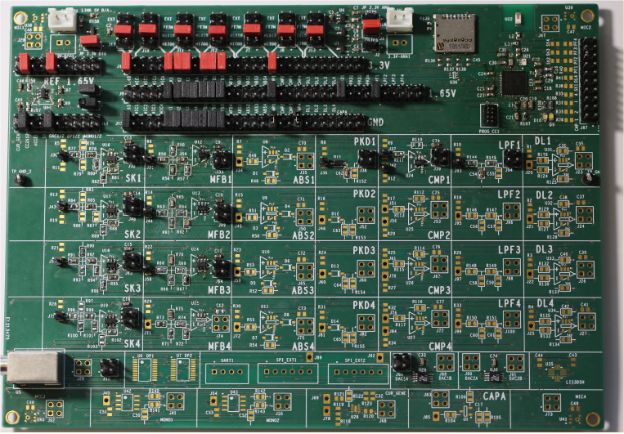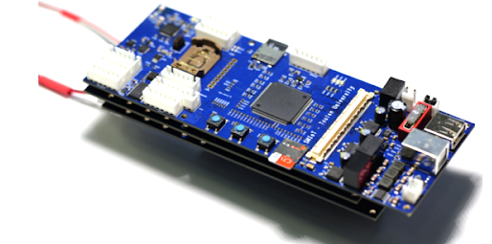
Fig.0 : IA embarquée : (a) Carte de développement mixte Analogique-numérique @im2np-Smiot, (b) carte JASON / QHB IA ULP SMIoT IM2NP LIS, déployée sur toutes les Antilles par l’OFB / MTES et par les Explorations de Monaco et FPA2.

Nous avons montré que le traitement mixte analogique-numérique des données permettra des gains énergétiques importants ainsi qu’une augmentation significative de la puissance de calcul in-situ (au niveau des capteurs). L’intégration complète du conditionnement (capteur) sur silicium faible coût CMOS 0.35um est l’une des perspectives pour les trois prochaines années. Quatre projets ANR notés A+ en 2021 on été posés par ce groupe, dont un par le pôle INPS; Sylvania, ULP Cochlée, CAts ainsi qu’un projet déposé avec le CEA. De plus les projets de développements JASON puis QHB sur SMioT sont l’aboutissement de 6 ans de recherche et sont l’état de l’art en la matière. L’Office Français pour la Biodiversité l’a validé pour son analyse des Antilles sur plusieurs années, ainsi que les Explorations de Monaco (Sphyrna Odyssey) et les missions de la MITI CNRS aux pôles.

C) Robotique et IA

En partenariat avec le LIS, le laboratoire IM2NP et Cosmer développent des thématiques qui trouvent leurs applications dans le cadre de l'IA pour l'exploration des milieux marins et maritimes.
Les deux thématiques principales concernent les systèmes multi-drones organisés en cordée et les interactions drone-plongeur, ou encore les ANR RoboSCo et ASTRID ANR/DGA de ces laboratoires dans ce Centre qui vient d'être accepté et qui porte sur les essaims de drones coopératifs sans communication numérique mais analogique, avec des applications dans le domaine marin (surface ou sous-marin) et en particulier bio-environnementales.
Les cordées de robots impliquent une gestion passive [Lar18, Lar20] ou active de l'ombilical qui les relie deux à deux. Les activités de recherche visent à contrôler la forme du câble (thèse en cours d’achèvement, intitulée Conception et pilotage synchronisés d’ombilicaux actionnés communicants : application à l’interconnexion de robots marins et sous-marins, financée par la région et l’UTLN) et son mouvement au cours de la progression des robots afin de leur permettre d'explorer des zones confinées de manière sécurisée, mais aussi de cartographier des zones de manière synchronisée (thèse en cours intitulée Localisation et commande d’une cordée de robots sous-marins en milieux confinés, financement MESR).
Les interactions drone-plongeur font intervenir un drone compagnon capable de communiquer avec des plongeurs et de leur rendre certains services : exécution d'ordres suite à reconnaissance de gestes, transport de matériel, aide à la formation, vigilance, surveillance, etc.
Ces activités sont développées dans le cadre du projet pluriannuel DPII (Drone Diver Intuitive Interaction), d’INPS/COSMER/LIS, en coopération avec la société Notilo-plus et la Cephismer, et co-financées par la région Sud PACA (thèse en cours intitulée amélioration des interactions drone-plongeur, co-financée par Notilo-plus).
Les moyens nécessaires pour rendre ces robots capables d'atteindre les objectifs fixés supposent la mise au point de capacités de navigation basées sur une perception locale de l'environnement (thèse en cours intitulée Système de localisation intelligent pour la navigation des robots sous-marins, financée par l’Ifremer) permettant d'adapter les algorithmes de SLAM, et de capacités sensorielles intelligentes en matière d'interaction multimodale avec l'humain. De plus, le robot au sein d'une cordée ou d'une palanquée de plongeurs doit être performant du point de vue de la mobilité et de la manoeuvrabilité, ce qui requiert l'intégration de techniques de contrôle robustes.
Le projet RAPID pluriannuel NARVAL (Navigation Autonome par Reconnaissance Visuelle et Acoustique pour la reLocalisation) porté par la société IVM Technologies et comprenant la société Notilo-plus ainsi que l’ENSTA Bretagne qui travaille en étroite collaboration avec le LIS sur les problématiques de positionnement multimodal (optique / acoustique) de drone sous-marin et ouvre les travaux poursuivis dans cette thématique au domaine de la défense via le Groupe des Plongeurs Démineurs (GPD) et le Centre d’Expertise des Programmes Navals (CEPN).
Par ailleurs, le laboratoire Cosmer, en partenariat avec le laboratoire LIS, s’intéresse également à la coordination multi-drones marins/sous-marins, permettant une couverture de zone étendue à des fins d’exploration ou de surveillance. Une thèse Cifre AID avec la société Alseamar est actuellement en cours sur la Coordination de flottes de planeurs sous-marins.

D) A OFFLINE pour détection signaux faibles et modélisation du milieux

La Chaire IA ADSIL est une colonne vertébrale de cet axe de recherche ICoB. Elle développe pour le LABORATOIRE de l’AGENCE INNOVATION DEFENSE (AID) et ANR Chaire IA, des algorithmes IA deep learning pour la reconnaissance de signaux faibles sous marins.
Par exemple, des reconnaissances automatiques des transitoires acoustiques sous-marins sont données Fig.7,8, pour des biosonars et des pulses de rorqual, analysés par nos modèles d’IA ‘deep learning’, qui permettent notamment de tester des hypothèses de détection ou de codage en milieux anthropisés.

Ces algorithmes sont en interaction avec ceux des ANR JCJC de R Marxer en traitement du son et de A Paiement en mesure astrophysique, tous deux participants à ce projet.
Ces 3 ANR courent sur les 3 à 4 ans à venir et sont structurantes pour UTLN (voir appel à projet Marcon AI Humanities Chaire IA) tant en axes de développement, recrutement qu’en enseignement.

De plus, ces algorithmes sont portés par les IA embarquées décrites plus haut. Ainsi un objectif est de répondre à “où et quand” déployer ces IA distribuées avancées. Pour apporter des éléments de réponse, notamment pour solutionner le problème de contrôle optimal associé, une approche performante consiste à simuler l'entièreté du système de mesure et d’interprétation. Un exemple est celui de la génération de trajectoires de cibles, ici des animaux marins pour l’exemple, intégrant l’ensemble de contraintes cinématiques et comportementales, à la chaîne de classification/détection/localisation par intelligence artificielle, en passant par des modélisations fines de la propagation acoustique. Ce “Serious Game”, générant des scénarios réalistes et admissibles, est une pierre angulaire de l’intégration de nos méthodes, pour résoudre le problème de déploiement optimal de nos observatoires. On notera que ces approches ont déjà été appliquées avec succès [Cho11,12] pour des problèmes similaires de déploiement de capteurs et de poursuite de cible (Fig.6).

ICoB ouvre des recherches duales avec des données terrain (Bouées, mission Sphyrna Odyssey, drones acoustiques, observatoires astrophysiques...), et par simulations notamment via le superordinateur national Jean Zay. Nous élaborons, intégrons et faisons interagir nos modules : production biosonar, propagation, reconnaissance automatique par IA des transitoires [Fer20ab,The21] (Fig.6).

E) Exemples d’expériences à l’échelle de ICoB en milieu marin
Nous donnons ci-dessous un exemple d’expériences à l’échelle de la Région menées par ICoB, notamment sur l'identification de bonnes représentations (Bal18, Bal19), algorithmes et architectures, pour calculer plus vite, plus précisément ou à moindre coût en milieu maritime. Plusieurs expériences seront développées dans ce cadre sur toute la durée de ce PIA4 ICoB, dans la lancée des missions en action depuis 6 à 2 ans: Sphyrna Odyssée, Bombyx, CARIMAM, mesures Antropophoniques, qui sont des réponses aux directives du Ministère et de l’europe (MedExemplaire, Minis. Mer MTES)

E1) Exemple sur territoire Varois / Côte Azur
Le milieu marin Toulonnais est atypique au niveau national, car influencé par la présence du courant liguro-provençal et par les mouvements verticaux dans toute sa colonne d’eau, dynamique complexe qui alimente une chaîne trophique du plancton aux super-prédateurs dont les mammifères marins. L’humain prend conscience de son implication dans la dégradation de ce milieu très anthropisé et plusieurs projets ont été développés, financés par les pouvoirs publics et laboratoires de recherche, de jeunes entreprises, d’Instituts de la mer, ou d’organismes directement impliqués dans les activités maritimes, dont les Explorations de Monaco et la Fondation Prince Albert II avec les Missions Sphyrna Odyssey 2018 2025. À Toulon, dans INPS, au cœur de cette dynamique, plusieurs laboratoires travaillent de concert, et certains de leurs travaux sont déjà mondialement reconnus.

Prenons comme la surveillance de la mégafaune méditerranéenne qui se concentre le long de ces falaises et dans les canyons de la côte varoise, offrant ainsi à la métropole de Toulon une position privilégiée au niveau international et unique pour leur étude. Ces espèces fragiles, dont la plupart sont menacées, sont les meilleurs indicateurs de l’état de santé de cet écosystème pélagique. Leur présence régulière atteste de son bon état de santé, car il ne peut y avoir de grands cétacés en abondance que si l’écosystème peut les nourrir. En revanche, la décroissance de leur population est un indice de la dégradation du milieu et des proies dont les cétacés dépendent. La préservation de ces espèces «parapluie» impose la préservation de l’ensemble de l’écosystème qui les supporte. Les fonctions uniques de la mégafaune océanique sont essentielles. «Si nous perdons des espèces, nous perdons des fonctions écologiques uniques… nous devons agir maintenant pour réduire les pressions humaines croissantes sur la mégafaune marine...» [Fuse20]. Réciproquement, la disparition de cette mégafaune aurait un impact sur cet écosystème des falaises sous-marines.

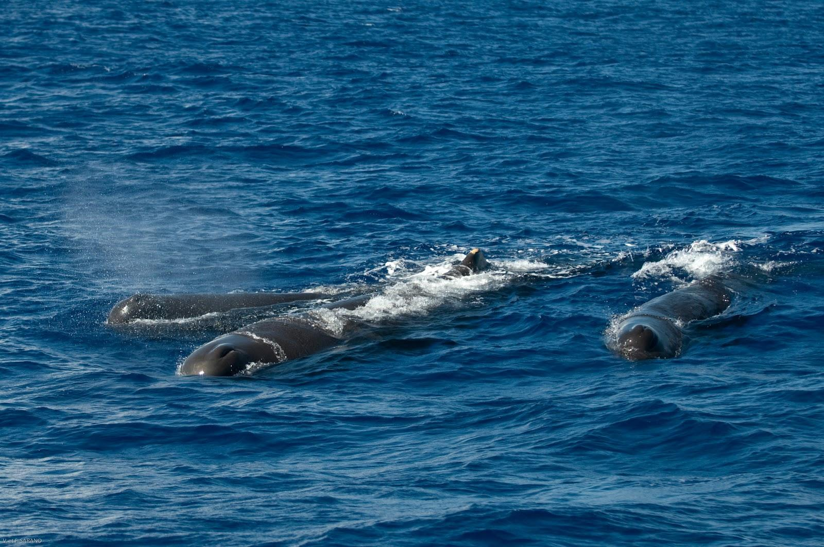 | 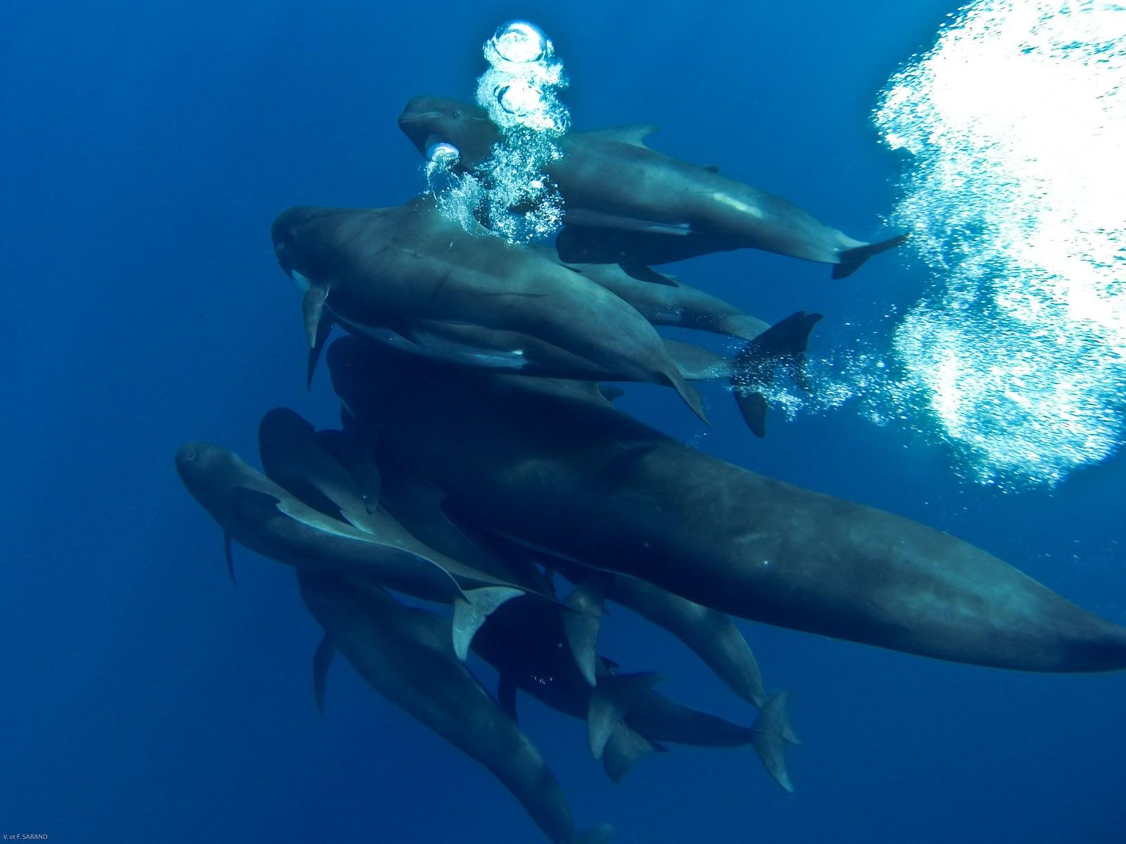 | 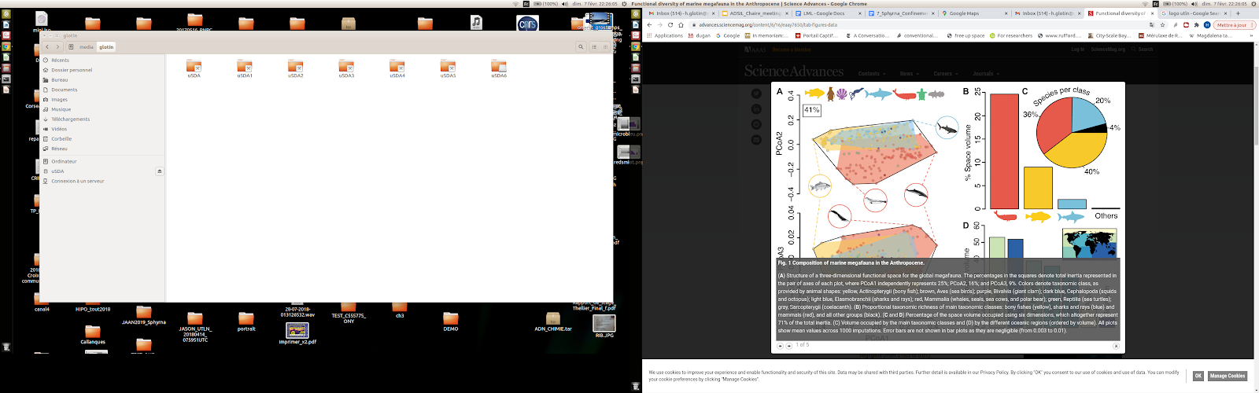
Fig.1: (a) Meute de 3 cachalots préparant leur sonde, (b) 15 globicéphales au large de Toulon, (c) Diversité fonctionnelle de la mégafaune marine [Fuse20], les cétacés en représentent 25% des fonctions et 36% des taxons.

La protection de ce milieu complexe passe par une meilleure compréhension et par le maintien d’une surveillance continue et de proximité du milieu. ICoB développe des recherches pluridisciplinaires en ce sens, en IA et robotique et contrôle et acoustique [Jen21, Glo21, Glo20, Pou20, Fer20a,b…], afin de discriminer, apprendre, modéliser, et finalement comprendre ce milieu complexe. En effet, pour ce qui est des cétacés notamment, l’acoustique est une des modalités les plus pertinentes pour l’étude de ces espèces parapluie (Fig.2-9). ICoB garantit des observations neutres et objectives et des modélisations à l’échelle océanique, c'est-à-dire dans des volumes de plusieurs km³ sans perturber l’écosystème. Les émissions sonores sont vitales aux cétacés, non seulement pour communiquer, mais également pour se repérer et pour chasser. Cette extrême dépendance acoustique rend les cétacés particulièrement vulnérables aux pollutions sonores anthropiques, dont la croissance suit l’explosion du trafic maritime. Les données acoustiques acquises depuis 7 ans par le réseau de surveillance mis en place par le LIS UTLN offrent un référentiel et un retour d’expérience unique au monde qui permettra de mesurer l’évolution concomitante des bruits anthropiques et de l’abondance des populations de cétacés, même les plus cryptiques.
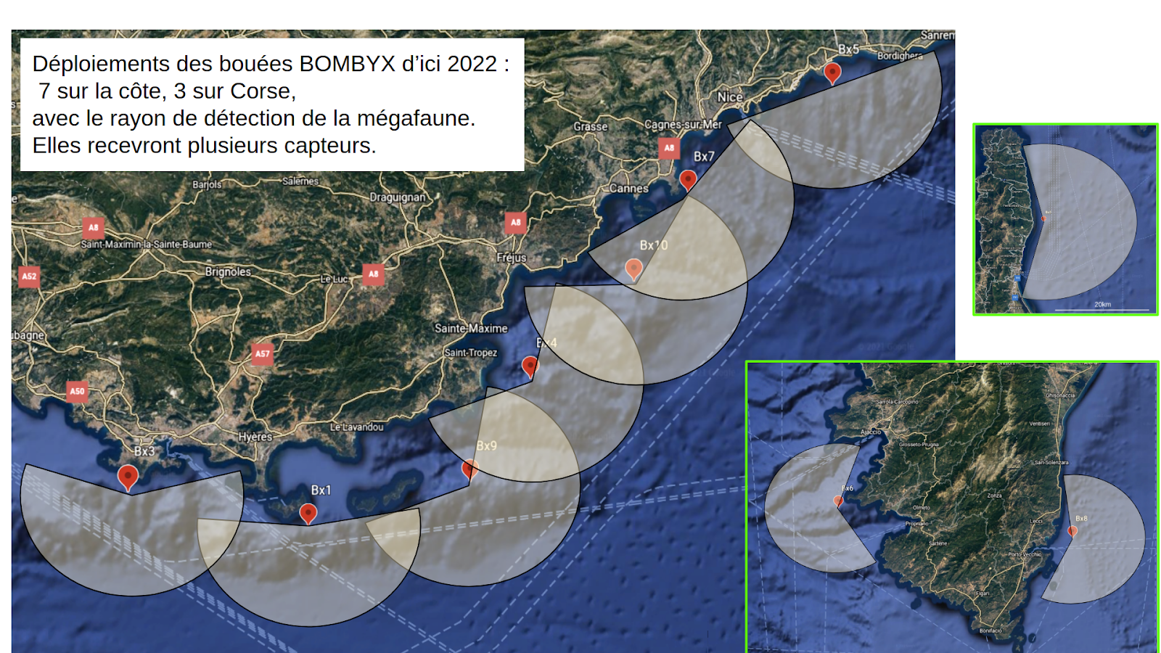 |  | 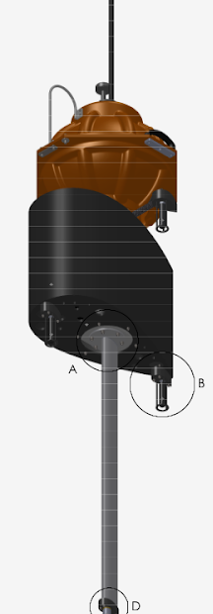
Fig. 2 : Déploiement des IA embarquées dans Bombyx 2, déployée en 18 mois dans Pelagos et pour 10 ans de fonction

Dès 2015, le LIS a construit et posé une bouée acoustique, stéréophonique, au large de Port-Cros (Bombyx Fig.2), en collaboration avec le MIO UTLN pour ses mesures océanographiques. Ces enregistrements, importants pour le SHOM notamment (convention en cours), contiennent les pistes des passages de la mégafaune (Cachalots, Globicéphales, Rorqual, Tursiops…). L’UTLN a acquis alors une expérience inédite au niveau international, car Bombyx1 était la première bouée bioacoustique long-terme stéréophonique. Nous présentons un exemple de ces observations relatives aux cachalots Fig.3.

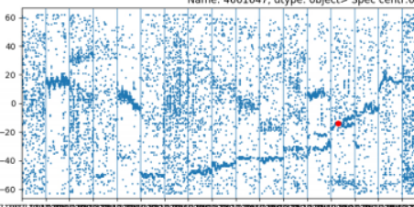
Fig.3 : Exemple de suivi de la population de cachalots au large de Toulon durant 4 ans par la bouée stéréophonique Bombyx1 au sud de Port-Cros, de 2015 à 2019 [Glotin 2017, Poupard 2020] (a) Trajectoire (en temps d’arrivée, 1bin = 1/50ks, ouverture inter-hydrophone=1.83m) d’un cachalot sur 3h (observation de 5 / 20min). [Poupard et al 2021 soumis à Nature Scientific Report]

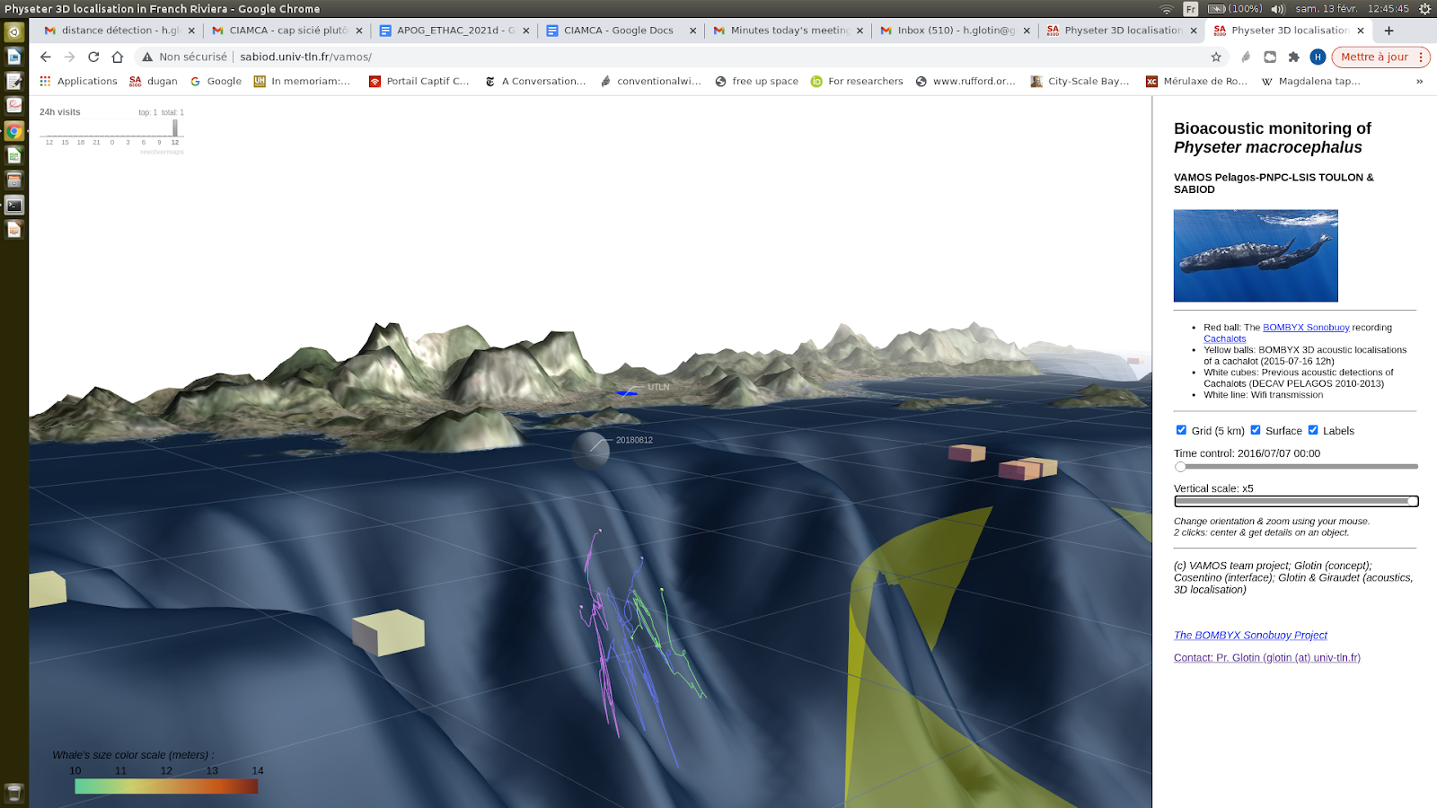 | 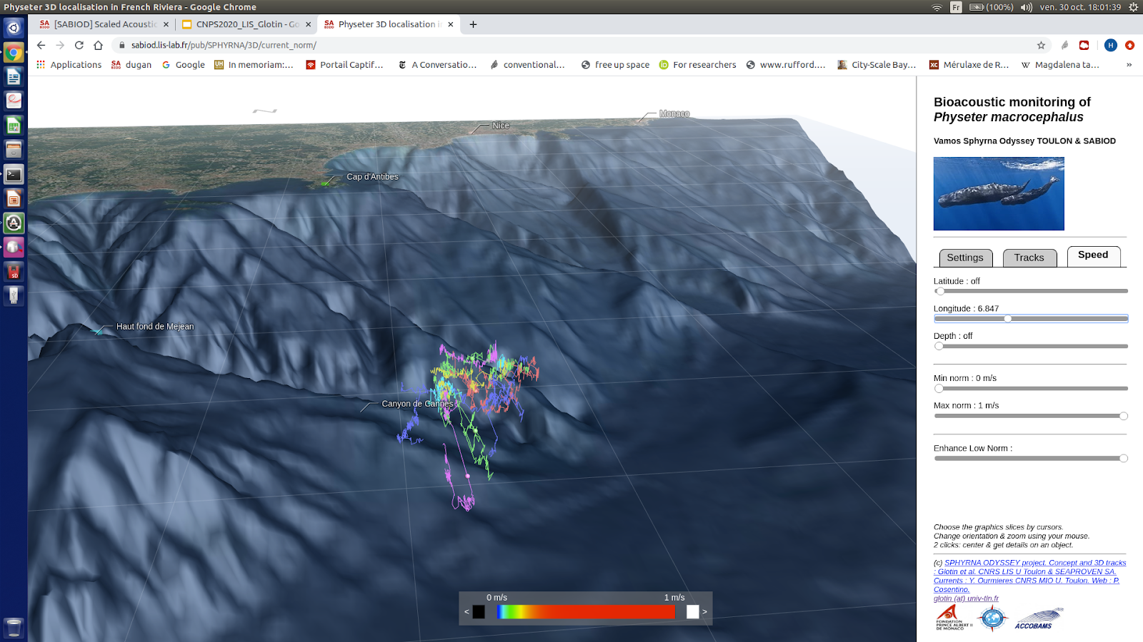
Fig.4 : sondes 3D calculées par acoustique passive depuis la surface (a) cachalot au cap Sicié [Pou19], (b) meute de 6 cachalots à Antibes (janv 2020), ces prédateurs restent concentrés 3h au centre d’un vortex (c), vers -1km [Glo20].

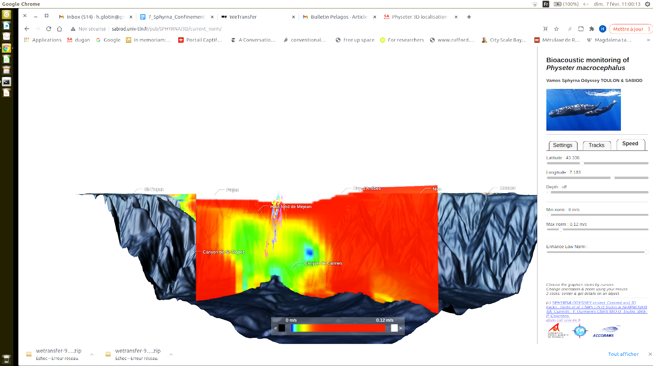 | 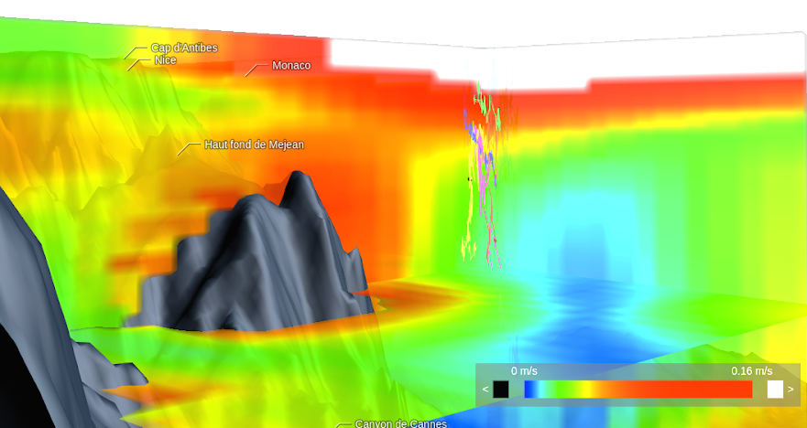
Fig.5 : Idem Fig.3, la meute chassant à 4mn du Mont Méjan. La norme locale des courants est pixélisée en couleur : on voit les pistes des cachalots pénétrer dans une colonne de fort gradient [Glo20]. Courants calculés par MIO, Y. Ourmières

ICoB repose en partie sur des années d’expertise et des Missions océanographiques comme Sphyrna Odyssey (SO) 2018-2019-2020... cofinancées par les Explorations de Monaco et La Fondation Albert II de Monaco et recoupant plusieurs dizaines de chercheurs de l’UTLN.
Ces recherches ont conduit au développement d’un système qui contribue de manière significative à notre compréhension de la mégafaune marine. Les algorithmes bioacoustiques IA de ICoB permettent de calculer en trois dimensions, les déplacements et les orientations relatives des mammifères marins dans plus de 1500m de colonne d’eau. Une découverte majeure est la mise en évidence de “Chasses en meute de cachalots” [Glo20] 2018-2019-2020.

Ces missions des Explorations de Monaco pilotées par UTLNs sont composées de deux robots / navires laboratoires autonomes (ALV Sphyrna, de Seaproven), équipés du système acoustique pentaphonique très haute vélocité conçu par le LIS et SMIoT à l’UTLN, et d’un ‘vaisseau amiral’ pour l’équipe scientifique qui reçoit les ondes acoustiques envoyées en temps-réel par chaque drone. Le pari pris consiste à écouter et localiser en 3D les cétacés à partir de minuscules antennes acoustiques mobiles situées près de la surface sous les coques des drones aux bonnes performances hydrodynamiques. SO 2018 a été la preuve de concept avec la construction de 3 trajectoires au large du Cap Sicié [Pou19]. La seconde mission a confirmé le protocole de septembre 2019 jusqu’au confinement de la COVID19 en mai 2020, dans le Sanctuaire Pelagos, en Méditerranée occidentale (Majorque et le Golfe du Lion).

SO a recueilli une masse de données de divers capteurs pour observer l’anthropophonie, les données physiques et chimiques et l’ADN environnemental avant et pendant la COVID 19, montrant les atténuations anthropophoniques et de polluants. SO a pour principaux objectifs l’écoute et la surveillance sans aucune interaction des populations de cétacés plongeant en eaux profondes, tels que les cachalots. Les individus sont donc étudiés dans leur habitat naturel au cours de leurs chasses en meute, collaborations bioacoustiques complexes abyssales. Le comportement des cétacés en plongée profonde est un indice pour l’évaluation de la biodiversité des abysses. Ces recherches permettent de dépeindre le comportement des cétacés dans les abysses sur la base de leur écholocalisation, clic par clic. Cette haute résolution semble montrer que les cachalots construisent un maillage d’émetteurs-récepteurs à une distance d’environ 500m les uns des autres, semblant user d’un principe de bio-multistatisme pour chasser: les informations engendrées par les sonars de chacun sont partagées par tous… à l’instar des systèmes humains de chasse sous-marine. Ces découvertes sont riches en perspectives sur la compréhension plus fine des perturbations anthropophoniques.

La structure des clics biosonars contient des informations temporelles et spectrales qui pourraient porter des signaux de communication superposés à leur fonction d’écholocation (Fig.7). Ces découvertes suggèrent, à moyen terme, de nouveaux critères concernant la pollution sonore et les systèmes anti-collision de ces superprédateurs des abysses avec le trafic maritime. Réciproquement, les pulses voisés pourraient porter en plus des dialectes, des informations d’écholocation (Fig.8).
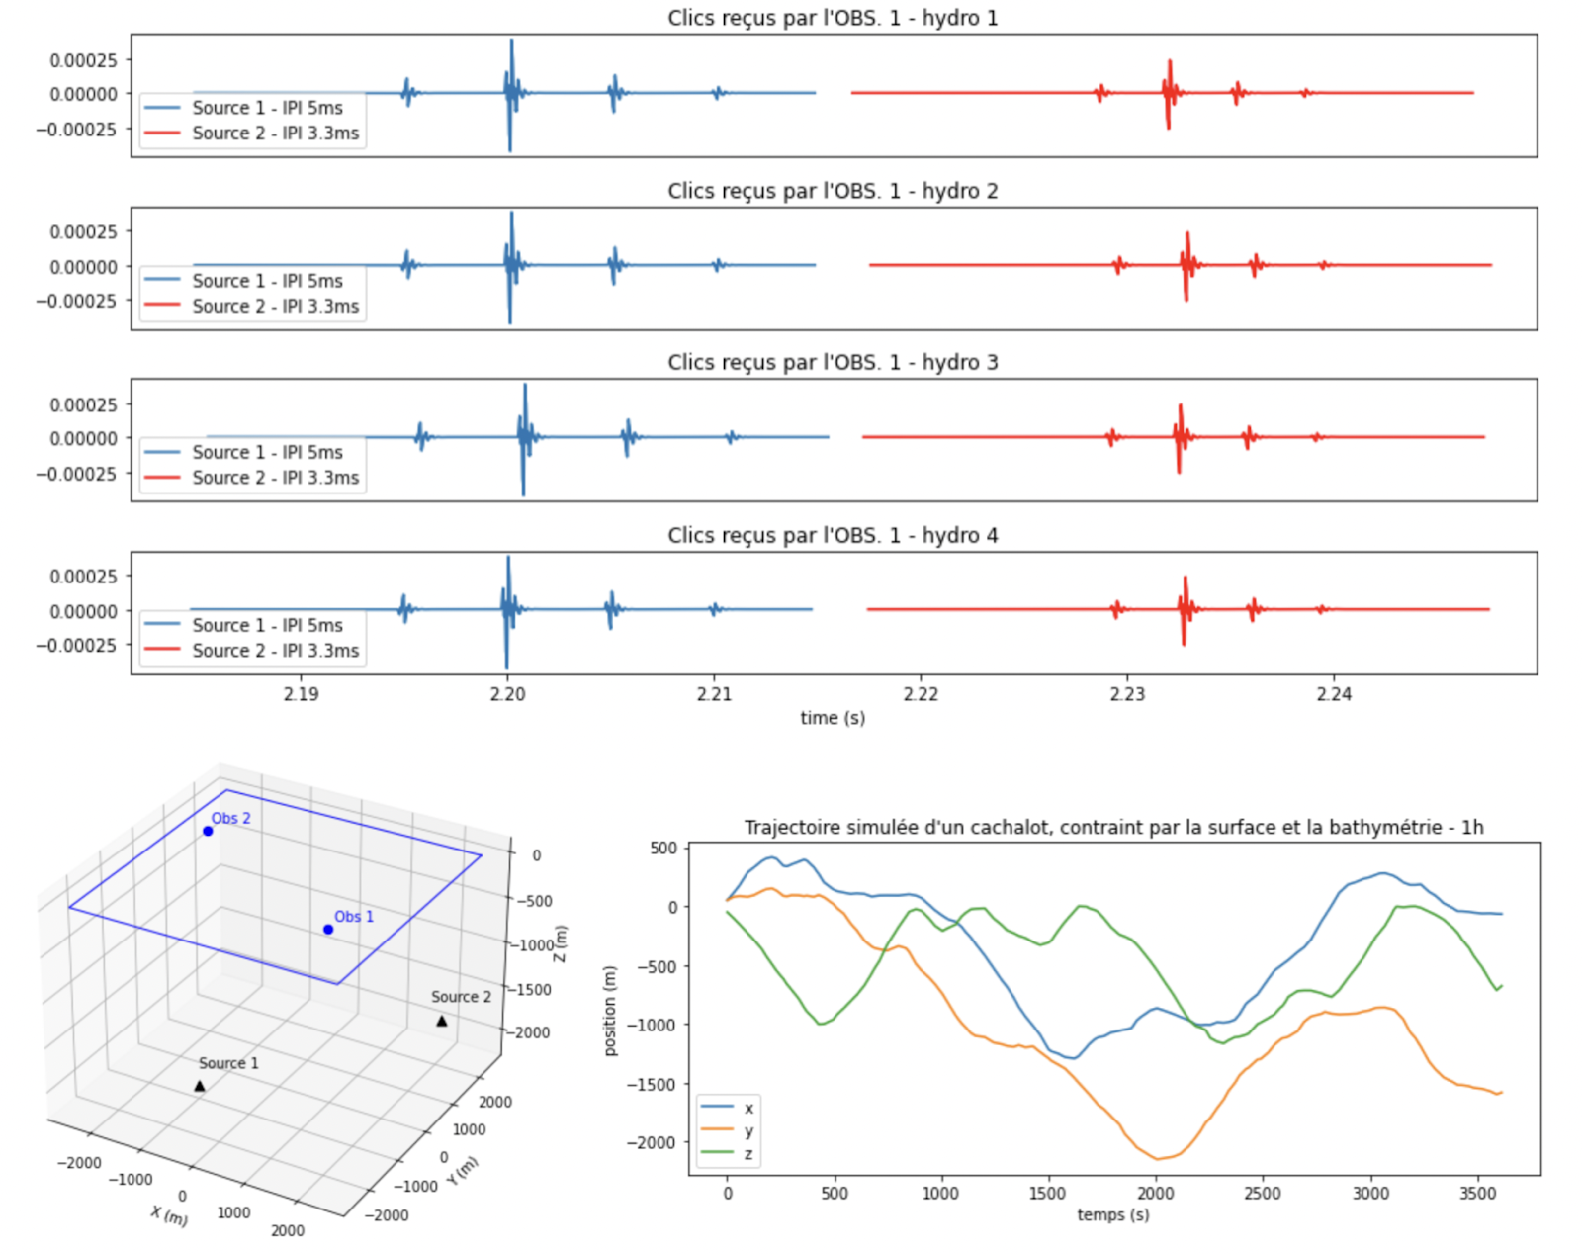
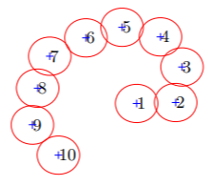
Fig.6 : “Serious Game” acoustique sous-marine en recherche à UTLN [The21] pour étudier les sondes de la mégafaune. Les trajectoires des sources sont générées suivant nos observations (c). Elles émettent des signaux (ici transitoires biosonar de cachalot par ondelette) le long de leur trajectoire. Ils sont réceptionnés (a) par chacun des Observateurs distribués dans l’espace, (b) suivant les nombreux degrés de liberté du simulateur: forme d’onde générée / modèle de source, modèle d'observateur, forme de déplacement, directivité et propagation de la source, bathymétrie, environnement… (d) Simulation de déploiement optimal spatio-temporel de capteurs pour maximiser la détection d’une source [Cho11,12].

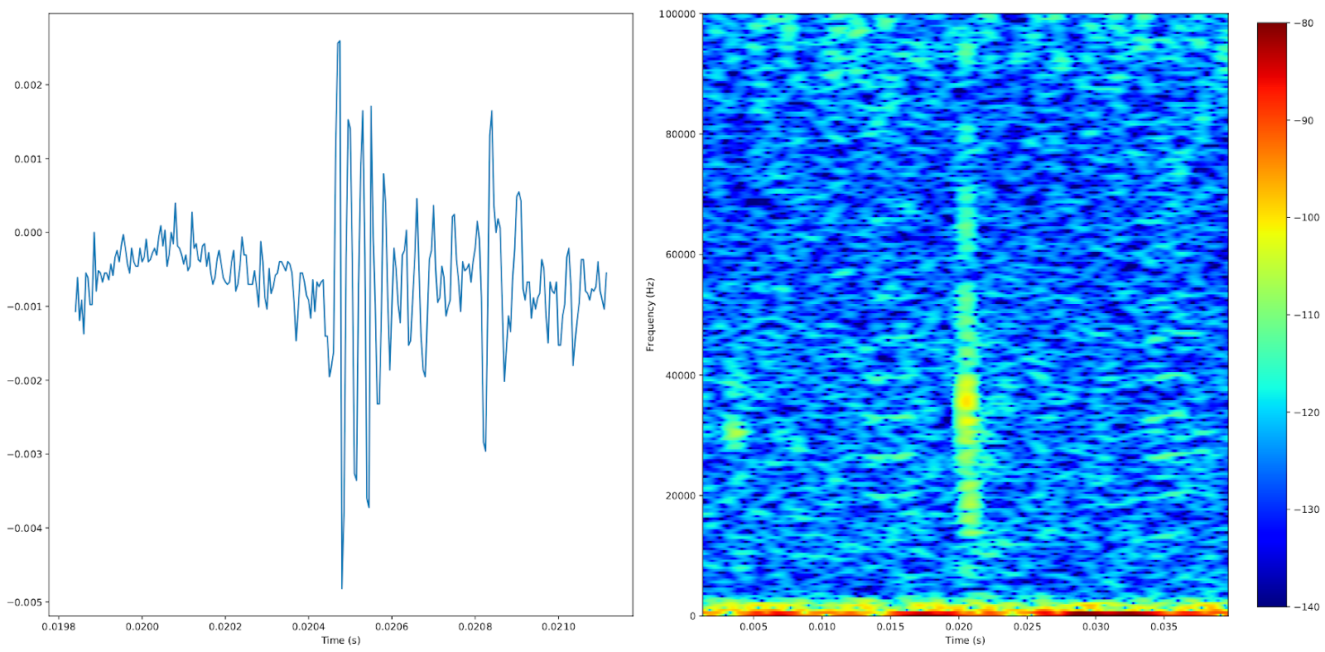 | 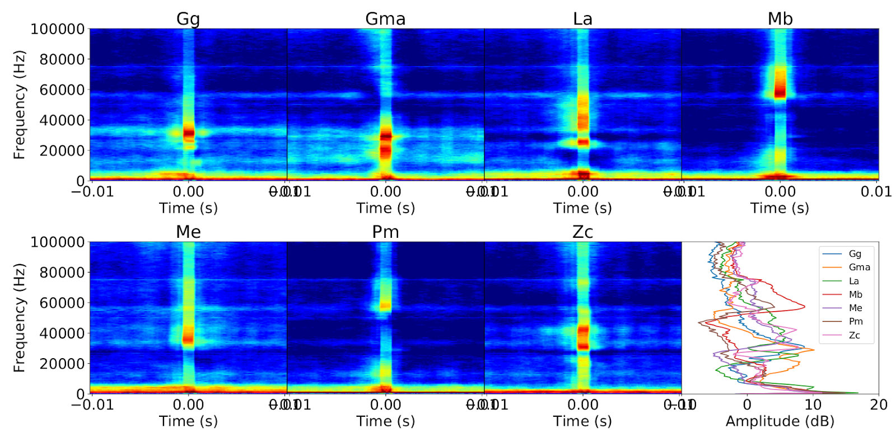 | 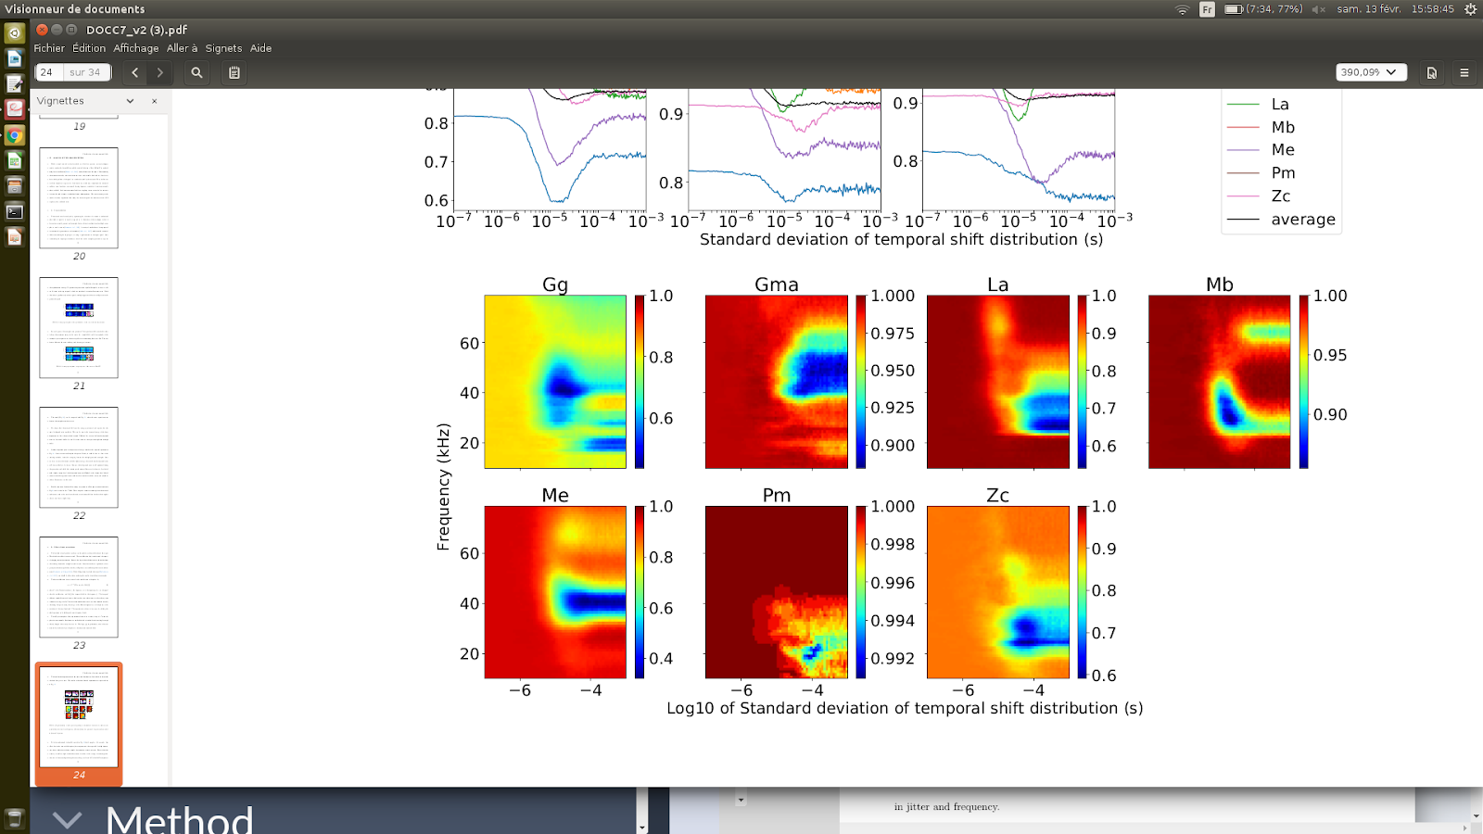
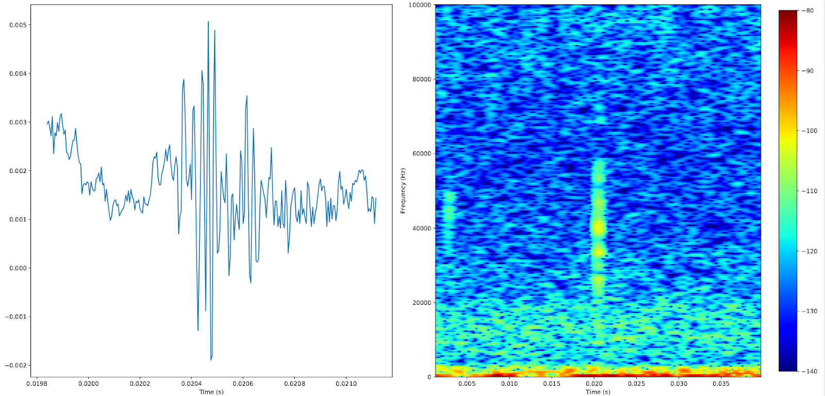
Fig. 7 : Exemple d’expérience par IA sur l’information temps-fréquence des biosonars. (Haut, Gauche) Forme d’onde (192kHz Fe, 16bits) et spectrogramme (largeur de bande 0, 0.1MHz) d’un Dauphin de Risso. (Milieu) Carte d’activation moyenne temps-fréquence d’un réseau de neurones (deep learning appris sur 20000 clics de cette espèce). (Droite) Indice de perte de performance de ce modèle IA du fait d’un déphasage des signaux originaux (déphasage croissant en abscisse, -4 vaut pour 2 bins de jitter). (Bas) idem pour la Baleine à Bec de Cuvier [Fer21]. Cette expérience démontre que le biosonar du Dauphin de Risso aurait un codage de phase bimodal (sur 20 et 40kHz), versus le Ziphius monomodal (30kHz). Cette approche par modèle permet une analyse des codes biosonars.

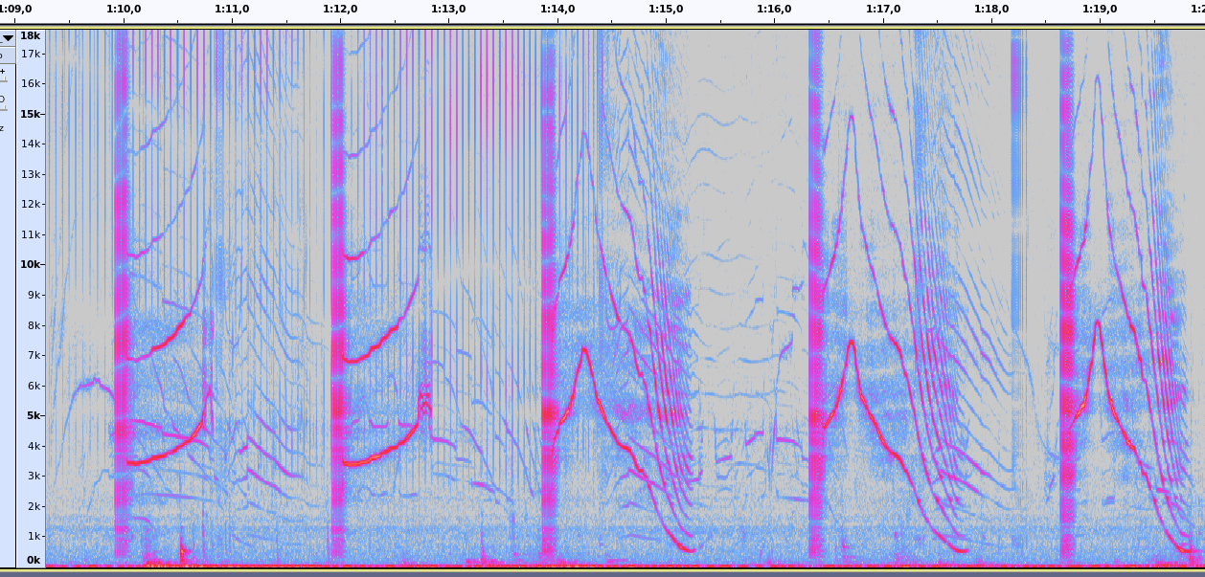 | 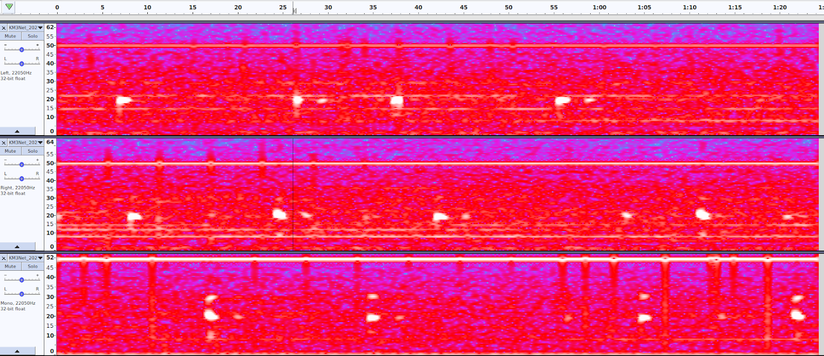 | 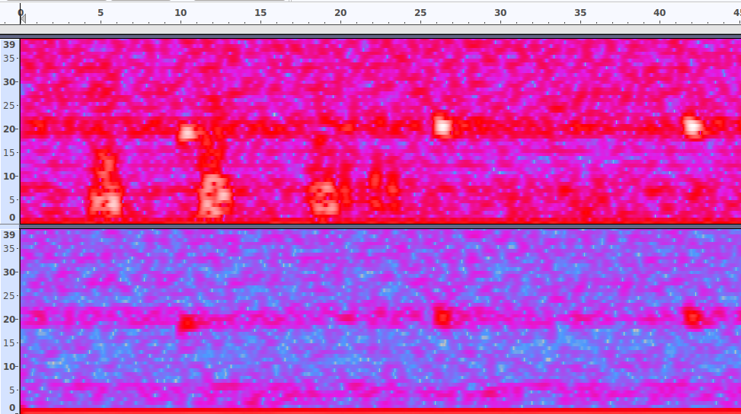
Fig. 8 : Exemple de vocalises: (Gauche) Globicéphales non loin de Toulon, 2020 [SO20] sur 20kHz de largeur de bande montrant la complexité de dialectes. (Milieu) Pulses de Rorqual Commun de Toulon Mai 2020 (spectrogrammes 0 à 40Hz, 20s) enregistrées pied de Porquerolle par KM3env par -2.5km de fond. (Droite) Idem depuis la bouée Bombyx1 -30m proche de Port-Cros en 2018, dans les deux cas détectées par réseau de neurones. Ces formes portent une information clanique [Pat19] qui pourrait être identifiée par IA et liée aux déplacements de populations accélérés par le réchauffement climatique.

E2) Autres exemples en recherches sur sites marins
Ces procédés sont identiques sur le suivi de la biodiversité et anthropophonie sur :
- Les Caraïbes que nous menons dans le projet OFB FEDER CARIMAM avec 20 partenaires internationaux,
- Les Fjords arctiques et antarctiques, Norvèges et Patagonie, avec les instituts polaires allemands, novégiens et chiliens,
- Nos collaborations avec Ocean Network Canada et AWI.de.

Nature Reserve “Isola di Montecristo”

Pilot project started in 2019 for the acoustic monitoring of the Marine Nature Reserve of the Isle of Montecristo with marine recorders, terrestrial recorders and photo/video traps. Project developed by UNIPV with the Biodiversity Department of Carabinieri. Specific aims of the project: evaluate the habitat use by dolphins and possibly detect the presence of the monk seal. On terrestrial habitats colonies of seabird will be monitored to evaluate their increase after the eradication (EU LIFE Project) of the invasive species rattus norvegicus .

F) Exemples de suivis bioacoustiques terrestres à stabiliser sur 10 ans ou développer ?

SABIOD-ITALY
In 2013 CIBRA/UNIPV and the University of Toulon (F) started a cooperative project named SABIOD to explore the use of new hardware and software technologies to study animal sounds and soundscapes. SABIOD-Italy, initially funded by CNRS through the Toulon University, has been developed with the approval, cooperation and logistic support of the Biodiversity Department of Carabinieri (formerly Italian Forestry Service (Corpo Forestale dello Stato - CFS). Aim of the project is the study of the soundscapes of the nature reserves managed by Carabinieri and of National Parks. The program started in 2014 in the Integral Nature Reserve of Sassofratino, in the core of the National Park "Foreste Casentinesi" and it is now extended to other areas of the National Park and to the Nature Reserves “Orecchiella”, “Lamarossa” and “Isola di Montecristo”. Other areas are being evaluated for the implementation of permanent acoustic monitoring. CIBRA/UNIPV is also partner of the project “Nature Guardians” developed by WWF-Italy and Huaweii for the real-time surveillance of Nature Reserves managed by WWF.

Fukushima survey
For now 6 year, Univ Toulon is in agreement with univ Tokyo towards bioacoustic survey of Fukushima fauna, ICoB will reinforce this collaboration (Fig. 9).

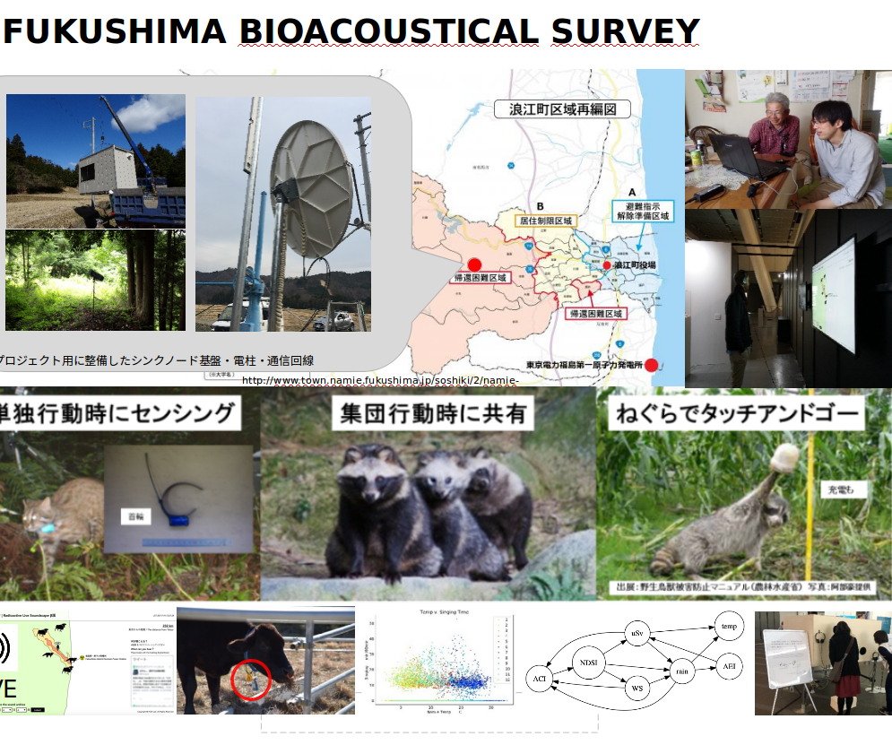
Fig. 9: Suivi bioacoustique à Fukushima, convention univ Tokyo et UTLN

Communication sensibilisation et capacité de charge au Parc national de port-cros
La sensibilisation des usagers a été identifiée comme un des leviers d'action pour la limitation du bruit anthropique. Depuis plusieurs années, nous livrons des expérimentations en partenariat avec le PNPC pour tenter d'améliorer les systèmes de communication auprès des usagers. Il s'agit de communiquer et sensibiliser afin de réduire le bruit généré par les visiteurs pour diminuer mécaniquement la pression anthropique sur les écosystèmes. La continuité de la collaboration interdisciplinaire est d'un intérêt double : d'un côté qualifier les systèmes de mesure, de l'autre estimer la performance des actions de sensibilisation.
Cet axe vise à exploiter les résultats des différents axes pour élaborer des marqueurs de médiation vers la société (critères d'acceptation, terminologie de sensibilisation, déclinaisons en typologie de destinataires). Les différents marqueurs appuieront des messages de sensibilisation ou de communication.

Suivi de régénération des Maures incendiés
Un suivi bioacoustique des Maures incendiés est lancé par notre groupe à travers la collaboration avec le LIS, ISYEB (MNHN), l’IMBE (AMU) et la Réserve Nationale Naturelle de la Plaine des Maures.
Ces suivis pourront aussi prendre en compte la Réserve Biologique du Massif des Maures et la Réserve biologique dirigée de la Mare de Catchéou (ONF du Var), ainsi que le PN de Port-Cros avec la thématique changement climatique

Suivi de la restauration de la faune dans une réserve au Mozambique (Maputo special Reserve)
Située dans l’une des régions du globe les plus riches pour sa biodiversité mais aussi là où elle est la plus menacée, la Réserve Spéciale de Maputo est un écosystème complexe, faite d’une mosaïque de lacs, prairies humides, forêts, savanes et mangroves. Sa grande faune ayant été décimée au cours de la guerre civile mozambicaine, elle fait l’objet d’une restauration volontariste par le biais de réintroduction d’animaux. L’objectif du programme de recherche est de suivre par la bioacoustique et sur une décennie l’évolution de la biodiversité dans les différents biotopes de la réserve. En partenariat étroit avec les acteurs locaux (gestionnaires de la réserve et chercheurs de l’université de Maputo) et l’université de Lisbonne, le laboratoire ENES de l’université de Saint-Etienne déploie des enregistreurs automatiques plusieurs fois dans l’année, sur plusieurs jours, dans une douzaine d’emplacements représentatifs de la diversité des biotopes (enregistrements continus,fréquence d’échantillonnage: 0 à 100 kHz). Des collaborations -incluant missions sur le terrain, mise en place de protocoles d’enregistrement et de mesure, analyses de signaux- sont en cours de développement avec le LIS et seront considérablement renforcées au travers de ICoB.

Suivi du réchauffement climatique
Nous avons des conventions avec le ministère des forêts du Québec pour son suivi bioacoustique depuis 3 ans. Cette thématique pourra également faire partie de la collaboration avec les réserves du Massif des Maures et du Parc National de Port Cros. En effet les zones témoins non incendiées pourront devenir des références de l’évolution temporelle de la biophonie terrestres et d’eau douce.

Suivi avifaune des Caraïbes
Nous sommes en convention avec l’OFB pour le suivi de l’avifaune des caraïbes.

Suivi d’espèces invasives par bioacoustique
Chacal doré dans la Plaine des Maures, Loup (?) et certains orthoptères. Une espèce aquatique est à monitorer : il s’agit de la punaise aquatique Anisops sardeus (Notonectidae), qui étend son aire de répartition depuis une vingtaine d'années, elle produit une signature sonore caractéristique.

Suivi d’espèces rares par bioacoustique
Plusieurs suivis d’espèces rares (au statut d'espèces protégées ou non), discrètes (peu visibles) peuvent être suivies par méthodes bioacoustiques. Dans les milieux terrestres plusieurs espèces méditerranéennes (oiseaux, mammifères dont Chiroptères, Reptiles, Amphibiens, et insectes) sont des espèces à fort enjeux de conservation qui peuvent être étudiés par les méthodes bioacoustiques. Le territoire du Var est entièrement situé dans un hotspot de biodiversité avec de nombreuses espèces à enjeux régionaux, nationaux et internationaux de conservation.

L’ensemble du projet d’écoute terrestre, a consolidé et à développer correspond donc bien à des enjeux territoriaux de l’USTV et à de fortes demandes des espaces protégés et des collectivités locales gestionnaires de l’environnement et de la biodiversité (gestion des espaces et des espèces, rôle de l'anthropophonie)

Par exemple la Réserve biologique du massif des Maures et la Réserve biologique dirigée de la Mare de Catchéou sont concernées par plusieurs espèces rares d’Anoures et d’insectes. La signature sonore de certaines espèces rares seront recherchées et monitorées. Deux thèses sur la bioacoustique des milieux terrestres forestiers méditerranéens est envisagée via ICoB entre MNHN, IMBE et le LIS et autres partenaires du projet pour des sites ateliers.

Plusieurs partenaires extérieurs de ICoB (comme l’ENES de l’université de St-Etienne) ont déjà des programmes de suivi d’espèces cibles (comme le lagopède alpin et le grand tétras) de grande ampleur impliquant l’Office Français de la Biodiversité. ICoB permettra de créer des synergies nouvelles avec le LIS et l’ensemble de l’écosystème “bioacoustique” prodigué par le projet.

Suivi de la biodiversité au niveau national
PIA3 TERRA FORMA et demonstrateur PSIBIOM
Mercantour, Alpes, Massif central, Pyrénées
Lien complémentarité avec PIA3s, montrer que ce sont des nouvelles actions !

Le laboratoire ENES de l’université de Saint-Etienne pilote un programme de suivi bioacoustique du lac du Bourget, le plus grand lac de France (programme Région AURA), et mène des recherches expérimentales sur les effets des bruits anthropiques dans les environnements d’eau douce. L’ENES développe également un partenariat avec le laboratoire CRIOBE de l’EPHE à Moorea pour l’utilisation de la bioacoustique en milieu récifal (impact des bruits anthropogéniques sur les poissons; suivi des activités anthropiques in situ par l’acoustique). Le projet ICoB permettra de créer des synergies scientifiques avec l’environnement toulonnais et les partenaires extérieurs (analyses de signaux longue durée, localisation des sources sonores en milieu aquatique).

G) Prévention / Legislation

Encore peu saisi par les juristes, le bruit en mer lié au développement des activités maritimes versus la protection de la biodiversité marine constitue, depuis plusieurs années, un sujet de recherche à part entière, notamment au Canada et aux États-Unis. La collaboration entre CERC et LIS est active et permet de promouvoir des interactions interdisciplinaires entre chercheurs, acteurs économiques, membres de la société civile et autorités administratives en vue de dégager des solutions pour concilier développement des activités maritimes et protection de la faune marine. Un état de la recherche sur le bruit en mer et les effets du trafic maritime sur la faune marine a été établi en Mai 2021 durant le colloque Bruit en Mer qui aboutit à un ouvrage piloté par notre groupe en septembre 2021 préfacé par la Ministre de la Mer.
Cet axe vise en SHS à tirer les enseignements des bilans des axes précédents et les remonter aux autorités, PREMAR, ministère etc qui les demandent pour légiférer et mesurer les efforts devant être déployés afin de réduire le bruit anthropique et limiter les impacts sur le milieu marin. Cet axe est soutenu par la Marine nationale, le MTES, le Ministère de la mer, et la PREMAR.

3. Teams
- Montrer comment le pilotage du projet renforce la stratégie de l’établissement /du regroupement (et éventuellement de l’Initiative d’excellence), sans créer un facteur de complexité supplémentaire.
- Décrire le processus et les flux de décisions au sein de l’organisation, notamment dans la gestion des points critiques ; mentionner le rôle des partenaires dans les prises de décision ; préciser la politique d’allocation des moyens, l’association des communautés, la diffusion des bonnes pratiques en interne et en externe.
- Préciser les systèmes d’assurance qualité qui seront mis en place et le processus d’auto-évaluation du dispositif.
- Dans le cas d’un projet conduit en partenariat, indiquer le cas échéant : les modalités d’organisation, de répartition des tâches, des moyens humains, d’accès aux ressources partagées, de valorisation des résultats et – lorsque cela est pertinent – d’ouverture des données, de protection et de partage de la propriété intellectuelle, de prise en compte des enjeux de souveraineté.
- Montrer les synergies développées entre les partenaires (entreprises, collectivités, Europe etc.) et les bénéfices attendus pour tous.
- Montrer comment l’établissement jouera plus encore, avec ce projet, son rôle de catalyseur des dynamiques territoriales.

ICoB groupe plusieurs institutions concentrées sur ces paradigmes connexes :
- Acoustique ; antenne ; signal faible ; apprentissage automatique IA de représentation du signal
- IoT ; Low power ; high sampling
- IA ; IA embarquée ; GPU ; deep learning
- Robotique et Contrôle Optimal
- Modèle & IA des dynamiques des courants et des vents ; upwelling ; courant de profondeur
- Estimation par IA du front océanique (avec Ocean Next SA et MIO)
- Signatures acoustiques : espèces (sur transitoires notamment) ; clan ; biométrie
- Suivi des comportements ; suivi des interactions entre individus identifiables
- Signature individuelle acoustique et génétique
- Communication biologique, langage non humain
- Théorie de l’information
- Anthropophonie : Champs Eolienne, Pétardage Travaux portuaires
- Sonar ; biosonar ; doppler
- Prédiction ; gestion de risque ; législation ; Droit en Mer
- Serious Game ; modèle ; prédiction.
- Arithmétique optimisée
- Ecologie, biologie de la conservation

Equipes
ICoB fédère chercheurs, groupes étatiques, entrepreneurs, autour d’un centre de recherche clairement identifié, visible par la région, transverse à leurs structures d’appartenance, et de permettre d'accroître leur dynamique et d’assurer un rayonnement fort de leurs résultats, et à une réelle amélioration de la situation écologique de la façade française de la Méditerranée nord-occidentale et sur d’autres sites du globe. Il s’agit aussi d’exporter par cette fédération et de projeter ce savoir ICoB UTLN sur Caraïbes, Polynésie, Nlle Calédonie, Mozambique ce qui rejoint une stratégie du ministère de la Mer et MTES en mer et terre, de rayonnement territorial, national et international.

Plusieurs thématiques et entités connexes sont listées dans la section suivante, montrant une quinzaine d’équipes, soit environ 30 Enseignants/Chercheurs thésards postdoc ou Ingénieurs sur UTLN dont la liste des principaux porteurs est Annexe 7

Projets sur lesquels s’adosse et structurés par ICoB
1 Chaire de RECHERCHE en INTELLIGENCE ARTIFICIELLE pour la bioacoustique sous marine (sur les 40 existant en Fr), 1.2 Million €
2 ANR bioacoustique et ULP, débutant en 2022 pour 3 ou 4 ans: ULPCochlea, ANR Sylvania, environ 3 Millions €
2 ANR JC IA en app. de représentation en écoute et signaux faible (20 en France environ), environ 2 Millions €
Projets internat en bioacoustique dont avec Office Fr Biodiversité, gouv Québec, Pelagos, PNPC, Monaco, environ 0.5 Million €
2 PIA3 ( 8 et 1.5 Millions d’euros ) PSIBIOM et TERRAFORM
ANR RoboSCo 1 Million €
ANR ASTRID DGA 1 Million €
5 Projets PACA / TPM (DPII, ROBOTCUP, BOMBYX, ETHAC, ADAPREDAT, environ 0.5 M€
Partenariat avec le Chili, Argentine, Bermudes, Pays Bas, Canada, Japon, Jamaïque…

Total projets connexes en cours à UTLN avec partenaires
= 18 Millions euros

Partenariat industriel avec OSEAN, SEAPROVEN GREENPRAXIS, NORTEKMED, IFREMER leaders en drones et Système embarqués,
STMICROELECTRONICS, OSEAN, SEMANTICTS, NavalGroup, Ocean Next, Aquasearch, CHORUS, SEAPROVEN, Notilo-plus, IVM Technologies, la Cephismer, CEPN, GPD, PLOCAN…

Partenariat avec PREMAR, ministère de la Mer, sur les questions anthropophoniques et bioacoustiques

1 projet EU internat IT FR en dépôt, un déposé avec la NORVEGE et le PORTUGAL (BIODIVERSA)
e, Norvège, …
Convention entre UTLN et univ de Tokyo, projet NORVEGIEN ASGARD en biophonie et robotique,
anciens projets FUI, ANR, ...
Chaire Institut universitaire de France et projet ERC en dépôt.

Thématique / Équipes de laboratoires connexes dans ICoB
- Bioacoustique: LIS, IM2NP, LAMFA (Univ. Jules Vernes), UNIPV
- IoT of the Ocean: SMioT, IM2NP, LIS
- Automatique, Robotique: LIS, COSMER
- Intelligence Artificielle: LIS, IM2NP, INRIA Nancy, Chaire IA ADSIL, Projet Eur. GIAS Interreg
- Acoustique: LMA (AMU), LAMFA, LIS, Longitude 181
- Instrumentation low power pour la mesure scientifique: IM2NP
- Modèle océanique surface et profond: MIO, IMATH, Longitude 181
- Dérive d’objet, pollution, carcasses, plastique en mer: LIS et MIO, et Ocean Next
- Drones pour l’exploration et la mesure distribuée: COSMER, SEAPROVEN, IFREMER
- Assimilation de données: LAMFA, LIS
- Codage: IMATH, LIS
- Opérateurs arithmétiques / IA sur composants bas niveau : IMATH, IM2NP
- Théorie de l’information: IMATH ; Théorie des langages: LIS, IMATH
- Serious Game: LIS, PREMAR, CROSSMED
- Bio-Multistatisme: LIS
- Gestion des risques et législation: PREMAR, CERC

Groupes externes liés à ICoB et Groupes R&D liés à ICoB

L’annexe contient une liste non exhaustive de partenaires actuels ou en activation, suivent quelques descriptions courtes.

UNIPV/CIBRA short description
Università degli Studi di Pavia - UNIPV
Dipartimento di Scienze della Terra e dell’Ambiente - DSTA
Centro Interdisciplinare di Bioacustica e Ricerche Ambientali – CIBRA
Banca Dati Spiaggiamenti - BDS
Via Taramelli 24 - 27100 PAVIA
http://www.unipv.it/cibra
http://mammiferimarini.unipv.it
The Centro Interdisciplinare di Bioacustica e Ricerche Ambientali (Interdisciplinary Center for Bioacoustics and Environmental Research) was founded in 1988 and is endowed with a Laboratory of Marine Bioacoustics and Acoustical Oceanography since 1989. The activity focuses on research projects on the acoustic communication in animals, the development of equipment and protocols for the monitoring and censusing with passive acoustics, the development of advanced sound analysis methods based on the digital processing of signals (computational bioacoustics), the establishment of a Digital Sound Library of Mediterranean Cetaceans and of Italian Nature Soundscapes as well as the technical support to other institutions involved in bioacoustic research and in nature conservation. Since 1998 CIBRA is involved in international research programs concerned with the design of mitigation protocols and tools to reduce the impact of anthropogenic noise on marine mammals and, more recently, on the preservation of terrestrial soundscapes with a dedicated Soundscape and Ecoacoustics Laboratory. Since 2006 CIBRA manages the National Stranding Network Database created on behalf of the Italian Ministry of the Environment. The data bank is Open Access and collects data on cetacean strandings occurring on the Italian coasts since 1986. Updated daily with data provided by institutional sources, it provides timely information on stranded species and on the causes of death. Since 2013 CIBRA runs the SABIOD-Italy project in cooperation with the University of Toulon and with the support of the Biodiversity Department of Carabinieri to access Integral Nature Reserves.

Pavia is also leading International Workshops:
- “Underwater Bioacoustics: Behavioural, Environmental & Evolutionary Perspectives”, E.Majorana Centre, Erice, I, 4-9/11/1994
- “XV IBAC” (International Bio Acoustic Council), Pavia, I, 24-26/10/1996
- “XXI IBAC”, Cogne, I, 3-6/09/2001
- “XVIII IBAC”, Pavia, I, 15-18/09/2007
- “4th Detection Classification and Localization of Marine Mammals” & “1st Density Estimation of Marine Mammals”, Pavia, I, 10-13/09/2009 funded by ONR
- “Cetacean echolocation and outer space neutrinos: ethology and physics for an interdisciplinary approach to underwater bioacoustics and astrophysical particles detection”, E.Majorana Centre, Erice, I, 17-21/10/2013
“Ecoacoustics Conference”, co-organizer, Urbino, I, 23-25/06/2021 (online)

Equipe de Neuro-Ethologie Sensorielle, Université de Saint-Etienne (ENES, Centre de Recherche en Neurosciences de Lyon, CNRS UMR 5292, Inserm UMR_S 1028)
L’ENES (eneslab.com) est un laboratoire de recherche dédié à la bioacoustique. Membre du Labex CeLyA (Centre Lyonnais d’Acoustique), l’ENES compte environ 25 chercheurs et chercheuses (9 statutaires, PhDs, Post-docs). A l’université de Saint-Etienne, l’ENES dispose d’un bâtiment dédié, récemment rénové (600 m2 comprenant des bureaux, des installations expérimentales, 9 salles insonorisées, et une animalerie (poissons - oiseaux - crocodiles - rongeurs). L’activité de recherche de l’ENES s’équilibre entre expériences au laboratoire et missions sur le terrain. La production scientifique de l’ENES est de haut niveau (publications régulières dans Nature Communications, Current Biology, Proc B, etc). Les projets de recherche de l’ENES s’étalent sur l’ensemble des problématiques de la bioacoustique: mécanismes des communications animales (production & perception des sons, codage de l’information dans les signaux sonores), évolution des communications, impact des bruits anthropogéniques, utilisation des outils de la bioacoustique pour le suivi d’espèces animales et le monitoring de la biodiversité. L’ENES pilote l’Ecole d’hiver en Bioacoustique (Bioacoustics Winter School, 15 jours de formation, 80 heures d’enseignement, conduisant à un Diplôme d’université) et le master international de bioacoustique (International master of Bioacoustics MoBi).

Institutions
Sanctuaire Pelagos, Parc National de Port-Cros, PREMAR, CROSSMED, AIDLab, Longitude 181 ONG, MIRACETI ONG…

PME
OSEAN (instrumentation acoustique et marine), SEAPROVEN (drones), SemanticTS (propagation), TRIPinLAB (sonification), NORTEKMED, IFREMER,…

4. REM sur Justification des moyens demandés
L’établissement coordinateur justifiera les moyens qu’il demande, sur la durée du projet, en indiquant les mécanismes qu’il mettra en œuvre pour attribuer ces moyens ainsi que ceux mis à disposition par les partenaires du projet, ou ceux qui seront obtenus en cofinancement par des tiers. L’articulation avec d’autres moyens obtenus au titre du Programme d’investissements d’avenir (PIA) sera détaillée et montrera qu’une même dépense ne sera présentée qu’à une seule action du PIA.
In ICoB, all requested grant is not covered by other cost / project.

5. References

[Abe13] Algorithmes d’extraction robuste de l’intervalle-inter pulse du biosonar du cachalot : applications éthologiques et suivi des populations, 2013, Abeille, thèse de doctorat UTLN, dir Glotin, Giraudet
[Bal19] Wavelet Learning by Adaptive Hermite Cubic Splines applied to Bioacoustic Chirps, R Balestriero, H Glotin, IEEE OCEANS 2019-Marseille, 1-5
[Bal18] Spline filters for end-to-end deep learning, R Balestriero, R Cosentino, H Glotin, R Baraniuk, International conference on machine learning, 2018, 364-373
[Bar20] “A novel low-power high speed accurate and precise DAQ with embedded artificial intelligence for long term biodiversity survey”, V. Barchasz, V. Gies, S. Marzetti, H. Glotin, e-Forum Acusticum 2020, 2020, Lyon, France. pp.3217-3224, ⟨10.48465/fa.2020.0875⟩. ⟨hal-03230835⟩
[Bes20] Deep Learning and Domain Transfer for Orca Vocalization Detection, 2020, Best, Ferrari, Poupard, Paris, Marxer,Symonds,Glotin (2020), In Joint conf. on neural networks. IEEE IJCNN, https://hal.archives-ouvertes.fr/hal-02865300/document
[Bou19] Behavioural responses of humpback whales to food-related chemical stimuli, 2019, Bouchard, Barnagaud, Poupard, Glotin, et al., PloSone 14.2
[Cho11] On the probability distribution of a moving target. Asymptotic and non-asymptotic results, 2011, Chouchane, Paris, Le Gland, Musso, Pham, in Information Fusion
[Cho12] Splitting method for spatio-temporal sensors deployment in underwater systems, 2012, Chouchane, Paris, Le Gland, Ouladsine, in Evolutionary Computation in Combinatorial Optimization
[Did20] Efficient modular operations using the adapted modular number system, Laurent-Stéphane Didier, Fangan-Yssouf Dosso, Pascal Véron, Journal of Cryptographic Engineering, Springer, 2020, ⟨10.1007/s13389-019-00221-7⟩
[Fer20a] 3D diarization of a sperm whale click cocktail party by an ultra high sampling rate portable hydrophone array for assessing individual cetacean growth curves, 2020, Ferrari, Glotin, Oger, Marxer, Asch, Gies, Sarano, Forum acusticum, https://hal.archives-ouvertes.fr/hal-03078655/document
[Fer20b] Docc10: Open access dataset of marine mammal transient studies and end-to-end Convolutional Neural Net classification, 2020, Ferrari, Glotin, Marxer, Asch, IJC Neural Net, https://hal.archives-ouvertes.fr/hal-02866091/document
[Fer21] Classification of Marine Mammal Clicks by Raw Audio Multiscale Hierarchical Convolutional Neural Network and a Study of Learned Representations, 2021, Ferrari, Glotin, Marxer, Asch, sub. in J. of American Soc of Acoustics, special issue on Machine Learning for Bioacoustics
[Fer20a] Study of a Biosonar Based on the Modeling of a Complete Chain of Emission-Propagation-Reception with Validation on Sperm Whales, Ferrari, 2020, Phd Thesis, Univ. Picardie Jules Verne & LIS UTLN https://hal.archives-ouvertes.fr/tel-03078625/document, dir Glotin, Asch
[Fuse20] Functional diversity of marine megafauna in the Anthropocene, Pimiento, Leprieur, Silvestro et al., Science Advances, 2020, V6N16, DOI:10.1126/sciadv.aay7650
[Glo20] SphyrnaOdyssey Report 1, Glotin, Thellier, Best, Poupard, Ferrari et al., 2020, http://sabiod.org/SO1.pdf
[Glo18] Anticollision system, GIAS Interreg project, 2019, Glotin et al., ICD OSEAN & UTLN
[Glo20] Chaire IA ADvanced underSea Intelligent Listening: ADSIL, 2020-24, Glotin, http://bioacoustics.lis-lab.fr
[Jen21] AI for current modelisation, 2020-23, Jenkins Phd Thesis, dir Glotin, Ourmière, Paiement
[Lar18] Catenary-based visual servoing for tether shape control between underwater vehicles, 2020, Ocean Engineering. Laranjeira, M., Dune, C. and Hugel V.
[Lar20] Local Vision-Based Tether Control for a Line of Underwater Robots. In 2018 IEEE Int. Conf. on Intelligent Robots (IROS) workshop. Laranjeira, M., Dune, C. and Hugel V.
[Mar21a] A ‘30 μW Embedded Real-Time Cetacean Smart Detector”, S. Marzetti, V. Gies, P. Best, V. Barchasz, S. Paris, H. Barthélémy, H. Glotin, Electronics 2021, 10, 819. https://doi.org/10.3390/electronics10070819
[Mar20] Ultra-Low Power Wake-Up for Long-Term Biodiversity, 2020, Monitoring,Marzetti, Gies, Barchasz, Best, Paris, Barthelemy, Glotin, in proc. IEEE IoTAIS
[Mar21b] “Ultra-Low Power Wake-Up for Long-Term Biodiversity Monitoring”, S. Marzetti, V. Gies, V. Barchasz, P. Best, S. Paris, H. Barthelemy, H. Glotin, 2020 IEEE International Conference on Internet of Things and Intelligence System (IoTaIS), 2021, pp. 188-193, doi: 10.1109/IoTaIS50849.2021.9359710.
[Pat19] Contributions en méthodes pour le suivi de mysticètes par acoustique passive, 2019, Patris, thèse de doctorat UTLN, dir Glotin, Asch
[Pou19] Real-time passive acoustic 3D tracking of deep diving cetacean by small non-uniform mobile surface antenna, 2019, Poupard, Ferrari, Schlüter, Marxer, Pavan, Glotin, IEEE Acoust. Sig & Speech Proc.
[Pou20] Contributions en Méthodes Bioacoustiques Multiéchelles: Spécifiques, populationnelles, individuelles et comportementales, Poupard, 2020, Phd Thesis, Univ. Toulon http://sabiod.org/pub/poupard/cv/m_poupard_phd_08012021.pdf, dir Glotin, Soriano, Lengagne
[Rob19] Efficient Fixed Base Exponentiation and Scalar Multiplication based on a Multiplicative Splitting Exponent Recoding, Jean-Marc Robert, Christophe Negre, Thomas Plantard, Journal of Cryptographic Engineering, Springer, 2019, 9 (2), pp.115-136. ⟨10.1007/s13389-018-0196-7⟩
[Sar20] Kin relationships in cultural species of the marine realm: case study of a matrilineal social group of sperm whales off Mauritius island, Indian Ocean, 2021, Sarano, Girardet, Sarano, Vitry, Preud’homme, Heuzey, Garcia-Cegarra, Madon, Delfour, Glotin, Adam, Jung, Royal Society Open Science 8:201794. https://doi.org/10.1098/rsos.201794
[The21] ‘Serious Game’ pour l’étude de la mégafaune, 2020-23, Thellier, Thèse Chaire IA ADSIL, dir Glotin, Paris, Marx

Reference of Univ Pavia ref since 2010

Pavan G., La Manna G., Zardin F., Internullo E., Kloeti S., Cosentino G., Speziale F., Riccobene G. & the NEMO Collaboration, 2008. Short Term and Long Term Bioacoustic Monitoring of the Marine Environment. Results from NEMO ONDE Experiment and Way Ahead. In: Computational bioacoustics for assessing biodiversity. Proceedings of the International Expert meeting on IT-based detection of bioacoustical patterns. Frommolt K.H., Rolf Bardeli R., Clausen M. (Eds.) Published by Federal Agency for Nature Conservation, Bonn, Germany: 7-14.

Pavan G., ACCOBAMS secretariat, 2010. Revised guidelines on anthropogenic noise. ACCOBAMS-SC6/2010/Doc 17.

Obrist M.K., Pavan G., Sueur J., Riede K., Llusia D. and Márquez R., 2010. Bioacoustic approaches in biodiversity inventories. In: Manual on Field Recording Techniques and Protocols for All Taxa Biodiversity Inventories, Abc Taxa, Vol. 8: 68-99. ISSN 1784-1283 (hard copy) ISSN 1784-1291 (on-line pdf) Available at: http://www.abctaxa.be/volumes/volume-8-manual-atbi/chapter-5/

Favali P., Chierici F., Marinaro G., Giovanetti G., Azzarone A., Beranzoli L., De Santis A., Embriaco D., Monna S., Lo Bue N., Sgroi T., Cianchini G., Badiali L., Qamili E., De Caro M.G., Falcone G., Montuori C., Frugoni F., Riccobene G., Sedita M., Barbagallo G., Cacopardo G., Calì C., Cocimano R., Coniglione R., Costa M., D’Amico A., Del Tevere F., Distefano C., Ferrera F., Valentina Giordano V., Massimo Imbesi M., Dario Lattuada D., Migneco E., Musumeci M., Orlando A., Papaleo R., Piattelli P., Raia G., Rovelli A., Sapienza P., Speziale F., Trovato A., Viola S., Ameli F., Bonori M., Capone A., Masullo R., Simeone F., Pignagnoli L., Zitellini N., Bruni F., Gasparoni F., Pavan G., et al. 2013. NEMO-SN1 Abyssal Cabled Observatory in the Western Ionian Sea. IEEE Journal of Oceanic Engineering 01/2013 38(2): 358 – 374.

La Manna G., Manghi M., Pavan G., Lo Mascolo F., Sarà G., 2013. Behavioural strategy of common bottlenose dolphins (Tursiops truncatus) in response to different kinds of boats in the waters of Lampedusa Island (Italy). Aquatic Conserv: Mar. Freshw. Ecosyst. 23: 745-757. DOI: 10.1002/aqc.2355

Pavan G., Fossati C., Caltavuturo G., 2013. Marine Bioacoustics and Computational Bioacoustics at the University of Pavia (Italy). Pp 3-25 in “Detection Classification and Localization of Marine Mammals using passive acoustics. 2003-2013: 10 years of international research.”, Adam O., Samaran F. (editors), 2013. DIRAC NGO (Paris, France): 1-298. ISBN 978-2-7466-6118-9.

Sciacca V., Caruso F., De Domenico E., Bellia G., Larosa G., Pavan G., Papale E., Pellegrino C., Pulvirenti S., Riccobene G., Simeone F., Viola S. for the SN1, EMSO and SMO Collaborations. "Deep-Sea multidisciplinary observatories: SMO & EMSO infrastructures for the long term acoustic monitoring of cetaceans". In: Istituto Nazionale di Fisica Nucleare - Laboratori Nazionali del Sud, Activity Report 2013-2014, pag. 151-152. ISSN:1827-1561.

Grammauta R., Viola S., Buscaino G., Caruso F., Chierici F., Embriaco D., Favali P., Giovanetti G., Larosa G., Pavan G., et al., 2015. Shipping noise evaluation from AIS data: A comparative study with longterm acoustic recordings from the EMSO-SN1 observatory in the Ionian Sea. Proceedings Underwater Acoustics Conference and Exhibition 2015, 21st to 26th June 2015 Platanias, Crete, Greece: 447-452.

Maglio A., Soares C., Bouzidi M., Zabel F., Souami Y., Pavan G., 2015. Mapping Shipping noise in the Pelagos Sanctuary (French part) through acoustic modelling to assess potential impacts on marine mammals. Sci. Rep. Port-Cros Natl. Park, 29: 167-185.

Pavan G., 2015. The Noise Issue: Case Studies in Italian Seas. In: Proceedings of The ECS/Ascobans/Accobams Joint Workshop On Introducing Noise Into The Marine Environment - What Are The Requirements For An Impact Assessment For Marine Mammals? Editor Evans P.G.H., ECS 2014, ECS Special Publication Series 58: 82-90.

Pavan G., Maglio A., Castellote M., Salivas M., Descroix-Comanducci F., 2015. Achieving underwater noise regulation through an ecosystem-based approach: the “Mediterranean strategy on Underwater Noise Monitoring”. Proceedings ECS Workshop “NEW MITIGATION METHODS AND EVOLVING ACOUSTIC EXPOSURE GUIDELINES”. Editors Wright A.J. & Robertson F.C., ECS 2015, ECS Special Publication Series 59: 42-50.

Pavan G., Favaretto A., Bovelacci B., Scaravelli D., Macchio S., Glotin H., 2015. Bioacoustics and Ecoacoustics Applied To Environmental Monitoring And Management. Rivista Italiana di Acustica, Vol. 39 (2015), N. 2, pp. 68-74.

Maglio A., Castellote M., Pavan G., Frey S., 2015. Overview of the noise hotspots in the ACCOBAMS area. Part I – The Mediterranean Sea. Report to ACCOBAMS. DOI: 10.13140/RG.2.1.2574.8560 https://www.researchgate.net/publication/290084063

Sciacca V., Caruso F., Beranzoli L., Chierici F., De Domenico E., Embriaco D., Favali P, Giovanetti G., Larosa G., Marinaro G., Papale E., Pavan G., Pellegrino C., Pulvirenti S., Simeone F., Viola S., Riccobene G., 2015. Annual Acoustic Presence of Fin Whale (Balaenoptera physalus) Offshore Eastern Sicily, Central Mediterranean Sea. PlosOne, 10(11): e0141838. doi:10.1371/journal.pone.0141838

Caruso F., Sciacca V., Bellia G., De Domenico E., Larosa G., Papale E., Pellegrino C., Pulvirenti S., Riccobene G., Simeone F., Speziale F., Viola S. Pavan G., 2015. Size Distribution of Sperm Whales Acoustically Identified During Long Term Deep-Sea Monitoring in the Ionian Sea. PlosOne, e. 0144503, DOI:10.1371/journal.pone.0144503

Knoll M., Ciaccia E., Dekeling R., Kvadsheim P., Liddell K., Gunnarsson S.L., Ludwig S., Nissen I., Lorenzen D., Kreimeyer R., Pavan G., Meneghetti N., Nordlund N., Benders F., van der Zwan T., van Zon T., Fraser L., Johansson T., and Garmelius M., 2016. Protection of Marine Mammals. In: “The Effects of Noise on Aquatic Life II, A.N. Popper, A. Hawkins (eds.)“, Advances in Experimental Medicine and Biology 875: 547-554. DOI 10.1007/978-1-4939-2981-8_66

Maglio A., Pavan G., Castellote M., Frey S., 2016. Progress report of a noise demonstrator: development of a demonstrator of a mediterranean impulsive noise register managed by ACCOBAMS. Report ACCOBAMS-MOP6/2016/Doc29

Lanfredi C, Azzellino A, D’Amico A, Centurioni L, Rella MA, Pavan G, Podestà M, 2016. Key Oceanographic Characteristics of Cuvier’s Beaked Whale (Ziphius cavirostris) Habitat in the Gulf of Genoa (Ligurian Sea, NW Mediterranean). J Oceanogr Mar Res, 4: 145. DOI: 10.4172/jomr.1000145

Sciacca V., Viola S., Pulvirenti S., Riccobene G., Caruso F., De Domenico E., Pavan G., 2016. Shipping noise and seismic airgun surveys in the Ionian Sea: Potential impact on Mediterranean fin whale. Proceedings of Meetings on Acoustics, 27 040010. [DOI: 10.1121/2.0000311]

Holst M., Smultea M.A., Koski W.R., Sayegh A.J., Pavan G., Beland J., Goldstein H.H., 2017. Cetacean Sightings and Acoustic Detections during a Seismic Survey off Pacific Central America, November–December 2004. Revista de Biología Tropical / International Journal of Tropical Biology and Conservation, 65(2). ISSN 2215-2075.

Pavan G., 2017. Fundamentals of Soundscape Conservation. In: “Ecoacoustics. The ecological role of sound” (Ed. Farina A. & Gage S.H.). Wiley: 235-258.

Fossati C., Mussi B., Tizzi R., Pavan G., Pace D.S., 2017., Italy introduces pre and post operation monitoring phases for offshore seismic exploration activities. Marine Pollution Bulletin 120 (1-2): 376-378

Viola S., Grammauta R., Sciacca V., Bellia G., Beranzoli L., Buscaino G., Caruso F., Chierici F., Cuttone G., Embriaco D., Giovanetti G., Favali P., Pavan G., Pellegrino C., Pulvirenti S., Riccobene G., Simeone F., (2017). Continuous monitoring of noise levels in the Gulf of Catania (Western Ionian Sea). Study of correlation with ship traffic. Marine Pollution Bulletin (2017), http://dx.doi.org/10.1016/j.marpolbul.2017.05.040

Caruso F., Alonge G., Bellia G., De Domenico E., Grammauta R., Larosa G., Mazzola S., Riccobene G., Pavan G., Papale E., Pellegrino C., Pulvirenti S., Sciacca V., Simeone F., Speziale F., Viola S. and Buscaino G., 2017. Long-Term Monitoring of Dolphin Biosonar Activity in Deep Pelagic Waters of the Mediterranean Sea. Scientific Reports, 7: 4321. DOI: 10.1038/s41598-017-04608-6

Drira A., Bouzidi M., Maglio A., Pavan G., Salivas M., 2018. Modelling underwater sound fields from noise events contained in the ACCOBAMS impulsive noise register to address cumulative impact and acoustic pollution assessment. EEA Proceedings EuroNoise 2018, ISSN: 2226-5147: 2819-2824. http://euronoise2018.eu/docs/papers/465_Euronoise2018.pdf

Podestà M., Pavan G., 2018. Risso's dolphin strandings in Italy: analysis of 31 years of data. Pagine 29 – 31 In: Lanfredi C., Remonato E. and Airoldi S. (Eds) 2018. Preliminary Report of the Mediterranean Grampus Project 2.0: Improving knowledge and conservation of the Mediterranean population of Risso's dolphins through effective partnerships. 50 pp. La Spezia, Italy, 7th April 2018.

Poupard M., Ferrari M., Schlüter J., Marxer R., Giraudet P., Barchasz V., Giès V., Pavan G., Glotin H., 2019. Real-time 3D passive acoustic tracking of cetacean by five non uniform aperture hydrophones mounted under autonomous surface vehicle. Proc. ICASSP 2019.

Pace D., Giacomini G., Campana I., Paraboschi M., Pellegrino G., Silvestri M., Alessi J., Angeletti D., Cafaro V., Pavan G., Ardizzone G., Arcangeli A., 2019. An integrated approach for cetacean knowledge and conservation in the central Mediterranean Sea using research and social media data sources. Aquatic Conserv: Mar Freshw Ecosyst. 2019 (29):1302–1323. DOI: 10.1002/aqc.3117

Righini R., Pavan G., 2019 First assessment of the soundscape of the Integral Nature Reserve “Sasso Fratino” in the Central Apennine, Italy. Biodiversity Journal. DOI: 10.1080/14888386.2019.1696229

Buzzetti F., Brizio C., Pavan G., "Beyond the audible: wide band (0-125 kHz) field investigation on Italian Orthoptera (Insecta) songs." Biodiversity Journal, 2020, 11 (2): 443–496 doi.org/10.31396/Biodiv.Jour.2020.11.2.443.496

Farina A., Righini R, Fuller S., Li P., Pavan G., 2020. Acoustic Complexity Indices reveal the acoustic communities of the old-growth Mediterranean forest of Sasso Fratino Integral Natural Reserve (Central Italy). Ecol Ind 120: 106927. https://doi.org/10.1016/j.ecolind.2020.106927

Pace D.S., Lanfredi C., Airoldi S., Giacomini G., Silvestri M., Pavan G. and Ardizzone D., 2021. Are Mediterranean sperm whale trumpets interaction calls in male-male context? Scientific Reports , 2021, 11:5867 https://doi.org/10.1038/s41598-021-84126-8

Romani F., Ramella Levis E., Posillico M., Opramolla G., Pavan G., 2021. Vocal repertoire of the eurasian griffon vulture (Gyps fulvus) in the central Apennines. Bioacoustics. https://doi.org/10.1080/09524622.2021.1925591

Peña-Carrillo K.I., Lorenzi M.C., Brault M., Devienne P., Lachaud J.P.,Pavan G., Poteaux C., 2021. A new putative species in the Ectatomma ruidum complex (Formicidae: Ectatomminae) produces a species-specific distress call. Bioacoustics. https://doi.org/10.1080/09524622.2021.1938226

References Lab. ENES (Univ St-Etienne) since 2010

2021
142.Juliette Linossier, Caroline Casey, Isabelle Charrier, Nicolas Mathevon and Colleen Reichmuth. 2021 Maternal
responses to pup calls in a high-cost lactation species. Biol. Lett. 17: 20210469.
141.Jack Falcón, Maria Jesus Herrero, Laura Gabriela Nisembaum, Esther Isorna, Elodie Peyric, Marilyn Beauchaud, Joël Attia, Denis Covès, Michael Fuentès, Maria Jesus Delgado and Laurence Besseau.2021. Pituitary Hormones mRNA
Abundance in the Mediterranean Sea Bass Dicentrarchus labrax: Seasonal Rhythms, Effects of Melatonin and
Water Salinity. Frontiers in Physiology. doi: 10.3389/fphys.2021.774975
140.Loïc Pougnault , Florence Levréro, Maël Leroux, Julien Paulet, Pablo Bombani, Fabrice Dentressangle, Laure Deruti, Baptiste Mulot and Alban Lemasson. (2021). Social pressure drives “conversational rules”in great apes. Biological Reviews. (2021), pp. 000–000
​139. Loïc Pougnault · Alban Lemasson · Baptiste Mulot · Florence Levréro (2021). Temporal calling patterns of a captive group of chimpanzees (Pan troglodytes) International Journal of Primatology.
138. Rojas, E., Thévenin, S., Montes, G., Boyer, N., & Médoc, V. (2021). From distraction to habituation: Ecological and behavioural responses of invasive fish to anthropogenic noise. Freshwater Biology DOI: 10.1111/fwb.13778
137. Pinheiro AP, Anikin A, Conde T, Sarzedas J, Chen S, Scott SK, Lima CF. 2021 Emotional authenticity modulates affective and social trait inferences from voices. Phil.Trans. R. Soc. B 376: 20200402.
136. Chiara De Gregorio, Daria Valente, Teresa Raimondi, Valeria Torti, Longondraza Miaretsoa, Olivier Friard, Cristina Giacoma,Andrea Ravignani,and Marco Gamba,. Categorical rhythms in a singing primate. Current Biology 31, R1363–R1380
135. Patricia Duchamp-Viret, Christine Baly. Plasticity Mechanisms at the Peripheral Stage of the Olfactory System. Psychology and Behavioral Science International Journal, Juniper Publishers, 2021, 17(3), pp.1-5. hal-03331026
134. Patricia Duchamp- Viret , Huu Kim Nguyen, Delphine Maucort- Boulch, Laurent Remontet, Aurore Guyon, Patricia Franco, Andrei Cividjian,Marc Thevenet, Jean Iwaz, Sonia Galletti, Behrouz Kassai, Elise Cornaton, Franck Plaisant, Olivier Claris, Hélène Gauthier- Moulinier. 2021 Protocol of controlled odorant stimulation for reducing apnoeic episodes in premature newborns: a randomised open- label Latin- square study with independent evaluation of the main endpoint (PREMODEUR). BMJ Open2021;11:e047141. doi:10.1136/ bmjopen-2020-047141
133. Karel Kleisner, Juan David Leongómez, Katarzyna Pisanski, Vojtěch Fiala, Clément Cornec, Agata Groyecka-Bernard, Marina Butovskaya, David Reby, Piotr Sorokowski and Robert Mbe Akoko. 2021 Predicting strength from aggressive vocalizations versus speech in African bushland and urban communities. The Royal Society B: Biological Sciences. Phil. Trans. R. Soc. B 376: 20200403
132. Juan David Leongómez, Katarzyna Pisanski, David Reby, Disa Sauter, Nadine Lavan, Marcus Perlmanand Jaroslava Varella Valentova. 2021 Voice modulation: from origin and mechanism to social impact. The Royal Society B: Biological Sciences. Trans. R. Soc. B 376: 20200386.
131. Anza S, Demuru E, Palagi E. 2021 Sex and grooming as exchange commodities in female bonobos’ daily biological market. Scientific reports, 19344
130. Pisanski K, Groyecka-Bernard A, Sorokowski P. 2021 Human voice pitch measures are robust across a variety of speech recordings : methodological and theoretical implications.Biol. Lett. 17: 20210356
129. Vieira M, Beauchaud M, Amorim C, Fonseca P, 2021. Boat noise affects meagre (Argyrosomus regius) hearing and vocal behaviour. Marine Pollution Bulletin 172, 112824.
128. Root-Gutteridge H, Ratcliffe VF, Neumann J, Timarchi L, Yeung C, Korzeniowska AT, Mathevon N and Reby D, 2021. Effect of pitch range on dogs’ response to conspecific vs. heterospecific distress cries. Scientific Reports.
127. Greenfield MD et al, 2021. Synchrony and rhythm interaction: from the brain to behavioural ecology. Philos. Transac. R Soc B 376, 20200324.
126. Greenfield MD et al, 2021. Rhythm interaction in animal groups: selective attention in communication networks. Philos. Transac. R Soc B 376, 20200338.
125. Frey, R, Wyman M.T., Johnston, M., Schofield, M., Locatelli, Y. and Reby, D. (2021). Roars, groans and moans: anatomical correlates of vocal diversity in polygynous deer. Journal of Anatomy.
124. Walter, K.V., Conroy-Beam, D., Buss, D.M., Asao, K., Sorokowska, A., Sorokowski, P… Pisanski, K. et al. (2021). Sex differences in human mate preferences vary across sex ratios. Proceedings of the Royal Society B: Biological Sciences.
123. Kleisner, K., Leongómez, J.D., Pisanski, K., Fiala, V., Cornec, C., Groyecka-Bernard, A., Butovskaya, M., Reby, D., Sorokowski, P., Mbe Akoko, R. (2021. Predicting strength from aggressive vocalisations in African bushland and urban communities. Philosophical Transactions of the Royal Society B.
122. Anikin, A. Pisanski, K., Massenet, M. & Reby, D (2021). Harsh is large: nonlinear vocal phenomena lower voice pitch and exaggerate body size. Proceedings of the Royal Society B: Biological Sciences.
121. Pisanski, K., Anikin, A. & Reby, D (2021). Vocal size exaggeration may have contributed to the origins of vocalic complexity. Philosophical Transactions of the Royal Society B.
120. Hannah Joy Kriesell, Thierry Aubin, Víctor Planas-Bielsaa, Quentin Schulle, Francesco Bonadonna, Clément Cornec, Yvon Le Maho, Laura Troudet, Céline Le Bohec 2021. How king penguins advertise their sexual maturity. Animal Behaviour 177 (2021) 253-267.
119. Livio Favaro, Eleonora Cresta, Olivier Friard, Katrin Ludynia, Nicolas Mathevon, Lorien Pichegru, David Reby, Marco Gamba 2021. Passive acoustic monitoring of the endangered African Penguin (Spheniscus demersus) using autonomous recording units and ecoacoustic indices. International journal of avian science IBIS (2021)
118. James W. E. Dickey . Neil E. Coughlan . Jaimie T. A. Dick .Vincent Medoc . Monica McCard . Peter R. Leavitt . Gerard Lacroix. Sarah Fiorini . Alexis Millot . Ross N. Cuthbert. 2021. Breathing space: deoxygenation of aquatic environments
can drive differential ecological impacts across biological invasion stages.Biological Invasions (2021)
117. Brochon J, Coureaud G, Hue C, Crochu B, Charrier I, 2021. Odor discrimination in terrestrial and aquatic environments in California sea lions (Zalophus californianus) living in captivity. Physiology & Behavior 235, 113408.
116. Cordoni G, Gioia M, Demuru E, Norscia I, 2021. The dark side of play: play fighting as a substitute for real fighting in domestic pigs, Sus scrofa. Animal Behaviour 175, 21-31.
115. Root-Gutteridge, H., Brown, L.P., Forman, J... and D. Reby (2021). Using a new video rating tool to crowd-source analysis of behavioural reaction to stimuli. Anim Cogn. https://doi.org/10.1007/s10071-021-01490-8
116. Pisanski, K., Reby, D. Efficacy in deceptive vocal exaggeration of human body size. Nat Commun 12, 968 (2021). https://doi.org/10.1038/s41467-021-21008-7
113. Cartei V, Oakhill J, Garnham A, Banerjee R, Reby D (2021). Voice Cues Influence Children’s Assessment of Adults’ Occupational Competence. Journal of Nonverbal Behavior.
​
2020
112. Pisanski, K. & Sorokowski, P. (in press). Human stress detection: Cortisol levels in stressed speakers predict voice-based judgments of stress. Perception.
111. Anikin A, Pisanski K, Reby D, 2020. Do nonlinear vocal phenomena signal negative valence or high emotion intensity? R Soc Open Sci 7, 201306
110. Papet L, Raymond M, Boyer N, Mathevon N, Grimault N, 2020. Crocodiles use both interaural level differences and interaural time differences to locate a sound source. The Journal of the Acoustical Society of America 148, EL307.
109. Garcia M, Theunissen F, Sèbe F, Clavel J, Ravignani A, Marin-Cudraz T, Fuchs J, Mathevon N, 2020. Evolution of communication signals and information during species radiation. Nature Communications 11, 4970.
108. Keenan S, Mathevon N, Stevens JM, Nicolè F, Zuberbühler K, Guéry JP, Levréro F, 2020. The reliability of individual vocal signature varies across the bonobo's graded repertoire. Animal Behaviour 169, 9-21.
107. Demuru E, Pellegrino F, Dediu D, Levréro F, 2020. Foraging postures are a potential communicative signal in female bonobos. Scientific Reports 10, 15431.
106. Green A, Clark CEF, Lomax S, Favaro L, Reby D, 2020. Context-related variation in the peripartum vocalisations and phonatory behaviours of Holstein-Friesian dairy cows. Applied Animal Behaviour Science 231,105089.
105. Cartei V, Oakhill J, Garnham A, Banerjee R, Reby D, 2020. “This is what a mechanic sounds like.” Children’s vocal control reveals implicit occupational stereotypes. Psychological Science.
104. Lemaire J, Mathevon N, Aubin T, Gaucher P, Marquis O, 2020. Observations on breeding site, bioacoustics and biometry of hatchlings of Paleosuchus trigonatus (Schneider 1801) from the French Guiana (Crocodylia: Alligatoridae). Herpetology Notes 13, 513-516.
103. Casey C, Charrier I, Mathevon N, Nasr C, Forman P, Reichmuth C, 2020. The genesis of giants: Behavioural ontogeny of male northern elephant seals. Animal Behaviour, 166, 247-259.
102. Pougnault L, Levréro F, Mulot B, Lemasson A, 2020. Breaking conversational rules matters to captive gorillas: A playback experiment. Scientific Reports 10, 6947. https://doi.org/10.1038/s41598-020-63923-7
101. Molbert N, Alliot F, Médoc V, Biard C, Meylan S, Jacquin L, Santos R, Goutte A, In press. Potential benefits of acanthocephalan parasites for chub hosts in polluted environments. Environmental Science and Technology
100. Walter KV, Conroy-Beam D, Buss DM, Asao K, Sorokowska A, Sorokowski P, ... Pisanski K,...& Amjad N, 2020. Sex differences in mate preferences across 45 countries: A large-scale replication. Psychological Science, 0956797620904154. https://doi.org/10.1177/0956797620904154
99. Gallego-Abenza M, Mathevon N, Wheatcroft D, 2020. Experience modulates an insect's response to anthropogenic noise. Behavioral Ecology 31, 90-96.
98. Bouchet H, Plat A, Levréro F, Reby D, Patural H, Mathevon N, 2020. Baby cry recognition is independent of motherhood but improved by experience and exposure. Proceedings of the Royal Society B 287(1921), 20192499.
97. Favaro L, Gamba M, Cresta E, Fumagalli E, Bandoli F, Pilenga C, Isaja V, Mathevon N, Reby D, 2020. Do penguins' vocal sequences conform to linguistic laws? Biology Letters 16(2), 20190589.
96. Pisanski K, Raine J, Reby D, 2020. Individual differences in human voice pitch are preserved from speech to screams, roars and pain cries. Royal Society Open Science 7(2), 191642.
95. Hanache P, Spataro T, Firmat C, Boyer N, Fonseca P, Médoc V, 2020. Noise-induced reduction in the attack rate of a planktivorous freshwater fish revealed by functional response analysis. Freshwater Biology 65, 75-85.
​
2019
94. Koseva BS, Hackett JL, Zhou Y, Harris BR, Kelly JK, Greenfield MD, Gleason JM, Macdonald SJ, 2019. Quantitative genetic mapping and genome assembly in the lesser wax moth Achroia grisella. G3: Genes, Genomes, Genetics, g3-400090.
92. Ravignani A, Verga L, Greenfield MD, 2019. Interactive rhythms across species: the evolutionary biology of animal chorusing and turn‐taking. Annals of the New York Academy of Sciences 1453, 12.
91. Rebar D, Barbosa F, Greenfield MD, 2019. Female reproductive plasticity to the social environment and its impact on male reproductive success. Behavioral Ecology and Sociobiology 73, 48.
90. Green A, Clark C, Favaro L, Lomax S, Reby D, 2019. Vocal individuality of Holstein-Friesian cattle is maintained across putatively positive and negative farming contexts. Scientific Reports 9, 18468.
89. Root-Gutteridge H, Ratcliffe VF, Korzeniowska AT, Reby D, 2019. Dogs perceive and spontaneously normalise formant-related speaker and vowel differences in human speech sounds. Biology Letters 15.
88. Amorim C, Fonseca PJ, Mathevon N, Beauchaud M, 2019. Assessment of fighting ability in the vocal cichlid Metriaclima zebra in face of incongruent audiovisual information. Biology Open 8.
87. Korzeniowska AT, Root- Gutteridge H, Simner J, Reby D, 2019. Audio–visual crossmodal correspondences in domestic dogs (Canis familiaris). Biology Letters 15: 20190564.
86. Sorokowski P, Oleszkiewicz A, Sorokowska A, Pisanski K, 2019. Human height preferences as a function of population size in the Cook Islands and Norway. American Journal of Human Biology e23367.
85. Cartei V, Banerjee R, Garnham A, Oakhill J, Roberts L, Anns S, Bond R, Reby D, 2019. Physiological and perceptual correlates of masculinity in children's voices. Hormones and behavior, 104616-104616.
84. Hyacinthe C, Attia J, Rétaux S, 2019. Evolution of acoustic communication in blind cavefish. Nature Communications 10, 4231.
83. Baudouin A, Gatti S, Levréro F, Genton C, Cristescu RH, Billy V, Motsch P, Pierre JS, Le Gouar P, Ménard N, 2019. Disease avoidance, and breeding group age and size condition the dispersal patterns of western lowland gorilla females. Ecology, e02786.
82. Papet L, Grimault N, Boyer N, Mathevon N, 2019. Influence of head morphology and natural postures on sound localization cues in crocodilians. Royal Society Open Science, 6(7), 190423.
81. Baciadonna L, Briefer EF, Favaro L, McElligott AG, 2019. Goats distinguish between positive and negative emotion-linked vocalisations. Frontiers in Zoology, 16: 25.
80. Sorokowski P, Puts D, Johnson J, Żółkiewicz O, Oleszkiewicz A, Sorokowska A, Kowal M, Pisanski K, 2019. Voice of Authority: Professionals Lower Their Vocal Frequencies When Giving Expert Advice. Journal of Nonverbal Behavior, 43: 257-269.
79. Raine J, Pisanski K, Bond R, Simner J, Reby D, 2019. Human roars communicate upper- body strength more effectively than do screams or aggressive and distressed speech. PLoS ONE 14 (3): e0213034.
78. Boets P, Laverty C, Fukuda S, Verreycken H, Britton RJ, Caffrey J. Goethals PLM, Pegg J, Médoc V, Dick JTA, 2019. Intra- and Intercontinental variation in the functional responses of a high impact alien invasive fish. Biological Invasions, 21: 1751-1762.
77. Marin-Cudraz T, Muffat-Joly B, Novoa C, Aubry P, Desmet JF, Mahamoud-Issa M, Nicolè F, Van Niekerk MH, Mathevon N, Sèbe F, 2019. Acoustic monitoring of rock ptarmigan: A multi-year comparison with point-count protocol. Ecological Indicators, 101: 710-719.
76. Levréro F, Touitou S, Frédet F, Nairaud B, Guéry JP, Lemasson A, 2019. Social bonding drives vocal exchanges in Bonobos. Scientific Reports, 9: 711.
​
2018
75. Koutseff A, Reby D, Martin O, Levréro F, Patural H, Mathevon N, 2018. The acoustic space of pain: Cries as indicators of distress recovering dynamics in preverbal infants. Bioacoustics, 27: 313-325.
74. Lemasson A, Peireira H, Levréro F, 2018 Social basis of vocal interactions in western lowland gorillas (Gorilla g. gorilla). Journal of Comparative Psychology, 132: 141-151.
73. Levréro F, Mathevon N, Pisanski K, Gustafsson E, Reby D, 2018. The pitch of babies’ cries predicts their voice pitch at age five. Biology Letters, 14: 20180065.
72. Sèbe F, Poindron P, Ligout S, Sèbe O, Aubin T, 2018. Amplitude modulation is a major marker of lamb bleats’ individual signature. Bioacoustics, 27: 359-375.
​
2017
71. Ben-Aderet T, Gallego-Abenza M, Reby D, Mathevon N, 2017. Dog-directed speech: why do we use it and do dogs pay attention to it? Proceedings of the Royal Society B: Biological Sciences, 284: 20162429.
70. Boucaud ICA, Perez EC, Ramos LS, Griffith SC, Vignal C, 2017. Acoustic communication in zebra finches signals when mates will take turns with parental duties. Behavioral Ecology, 28: 645-656.
69. Chabrolles L, BenAmmar I, Fernandez MSA, Boyer N, Attia J, Fonseca PJ, Amorim CP, Beauchaud M, 2017. Appraisal of unimodal cues during agonistic interactions in Maylandia zebra. PeerJ, 5: e3643.
68. Chabrolles L, Coureaud G, Boyer N, Mathevon N, Beauchaud M, 2017. Cross-sensory modulation in a future top predator, the young Nile crocodile. Royal Society Open Science, 4: 170386.
67. Fernandez MSA, Vignal C, Soula HA, 2017. Impact of group size and social composition on group vocal activity and acoustic network in a social songbird. Animal Behaviour 127: 163-178.
66. Garcia M, Favaro L, 2017. Animal vocal communication: function, structures, and production mechanisms. Current Zoology, 63: 417-419.
65. Genton C, Cristescu R, Gatti S, Levréro F, Bigot E, Motsch P, LeGouar P, Pierre JS, Menard N, 2017. Using demographic characteristics of populations to detect spatial fragmentation following suspected ebola outbreaks in great apes. American Journal of Physical Anthropology, 164: 3-10.
64. Griffith SC and 50 others (including Boucaud ICA, Villain AS, Vignal C), 2017. Variation in reproductive success across captive populations: methodological differences, potential biases and opportunities. Ethology, 123: 1-29.
63. Kelly T, Reby D, Levréro F, Keenan S, Gustafsson E, Koutseff A, Mathevon N, 2017. Adult human perception of distress in the cries of bonobo, chimpanzee and human infants. Biological Journal of the Linnean Society, 120: 919–930.
62. Mathevon N, Casey C, Reichmuth C, Charrier I, 2017. Northern elephant seals memorize the rhythm and timbre of their rivals’ voices. Current Biology, 27: 2352-2356.
61. Mouterde S, Elie J, Mathevon N, Theunissen F, 2017. Single neurons in the avian auditory cortex encode individual identity and propagation distance in naturally degraded communication calls. The Journal of Neuroscience 37: 3491-3510.
60. Ravignani A, Gross S, Garcia M, Rubio-Garcia A, de Boer B, 2017. How small could a pup sound? The physical bases of signaling body size in harbor seals. Current Zoology, 63: 457-465.
59. Villain A, Mahamoud-Issa M, Doligez B, Vignal C, 2017. Vocal behaviour of mates at the nest in the White-throated Dipper Cinclus cinclus: contexts and structure of vocal interactions, pair-specific acoustic signature. Journal of Ornithology, 158: 897-910.
​
2016
58. Boucaud I, Aguirre-Smith M, Valere P, Vignal C, 2016. Incubating females signal their need during intrapair vocal communication at the nest: a feeding experiment in great tits. Animal Behaviour, 122: 77-86.
57. Boucaud ICA, Mariette M, Villain AS, Vignal C, 2016. Vocal negociation over parental care? Acoustic communication at the nest predicts partners’ incubation share. Biological Journal of the Linnean Society, 2: 322-336.
56. Boucaud ICA, Valère PA, Aguirre Smith P, Doligez B, Cauchard L, Rybak F, Vignal C. 2016. Interactive vocal communication at the nest by parent great tits Parus major. Ibis, 158: 630-644.
55. Curé C, Mathevon N, Aubin T. 2016. Mate vocal recognition in the Cory’s shearwater Calonectris diomedea: Do females and males share the same acoustic code? Behavioural Processes, 128: 96-102.
54. Fernandez MSA, Soula H, Mariette M, Vignal C, 2016. A new semi-automated method for assessing avian acoustic networks reveals that juvenile and adult zebra finch have separate calling networks. Frontiers in Psychology, 7: 1816.
53. Fouquet M, Pisanski K, Mathevon N, Reby D, 2016. Seven and Up: Voice pitch in childhood predicts voice pitch in adulthood. Royal Society Open Science, 3: 160395.
52. Hernandez AM, Perez EC, Mulard H, Mathevon N, Vignal C, 2016. Mate call as reward: Acoustic communication signals can acquire positive reinforcing values during adulthood in female zebra finches (Taeniopygia guttata). Journal of Comparative Psychology, 130: 36-43.
51. Keenan S, Mathevon N, Steven JMG, Guéry JP, Zuberbuhler K, Levréro F, 2016. Enduring voice recognition in bonobos. Scientific Reports, 6: 22046.
50. Ligout S, Dentressangle F, Mathevon N, Vignal C, 2016. Not for parents only: Begging calls allow nest-sibling recognition in juvenile zebra finches. Ethology, 122: 193-206.
49. Perez EC, Mariette MM, Cochard P, Soulage CO, Griffith SC, Vignal C, 2016. Corticosterone triggers high-pitched nestlings’ begging calls and affects parental behavior in the wild zebra finch. Behavioral Ecology, 27: 1665-1675.
48. Prior N, Nian Yap K, Tian Qi DL, Vignal C, Soma KK, 2016. Context-dependant effects of testosterone treatment to males on pair maintenance behaviour in zebra finches. Animal Behaviour, 114: 155-164.
47. Quispe R, Sèbe F, da Silva ML, Gahr M, 2016. Dawn-song onset coincides with increased HVC androgen receptor expression but is decoupled from high circulating testosterone in an equatorial songbird. Physiology & behavior, 156: 1-7.
46. Reby D, Levréro F, Gustafsson E, Mathevon N, 2016. Sex stereotypes influence adults’ perception of babies’ cries. BMC Psychology, 4: 19.
45. Villain AS, Fernandez MSA, Bouchut C, Soula HA, Vignal C, 2016. Songbird mates change their call structure and intra-pair communication at the nest in response to environmental noise. Animal Behaviour, 116: 1-17.
​
2015
44. Casey C, Charrier I, Mathevon N, Reichmuth C, 2015. Rival assessment among elephant seals: evidence of associative learning during male-male contests. Royal Society Open Science 2: 150228.
43. Chabert T, Colin A, Aubin T, Shacks V, Bourquin S, Mathevon N, 2015. Size does matter: Nile crocodile mothers react more to the voice of smaller juveniles. Scientific Reports 5: 15547.
42. Elemans CPH, Rasmussen JH, Herbst CT, During DN, Zollinger SA, Brumm H, Srivastava K, Svane N, Ding M, Larsen OL, Sober SJ, Svec JG, 2015. Universal mechanisms of sound production and control in birds and mammals. Nature Communications, 6: 8978.
41. Elie JE, Soula H, Mathevon N, Vignal C, 2015. Housing conditions and sacrifice protocol affect neural activity and vocal behavior in a songbird species, the zebra finch (Taeniopygia guttata). Comptes Rendus Biologie, 338: 825-837.
40. Genton C, Pierre A, Cristescu R, Levréro F, Gatti S, Pierre JS, Ménard N, Le Gouar P, 2015. How Ebola impacts social dynamics in gorillas: a multistate modelling approach. Journal of Animal Ecology, 84: 166-176
39. Levréro F, Carrete-Vega G, Herbert A, Lawabi I, Courtiol A, Willaume E, Kappeler PM, Charpentier MJE, 2015. Social shaping of voices does not impair phenotype matching of kinship in mandrills. Nature Communications, 6: 7609.
38. Perez EC, Elie JE, Boucaud ICA, Crouchet T, Soulage CO, Soula HA, Theunissen FE, Vignal C, 2015. Physiological resonance between mates through calls as possible evidence of empathic processes in songbirds. Hormones and Behavior, 75: 130-141.
37. Perez EC, Fernandez MSA, Griffith SC, Vignal C, Soula HA, 2015. Impact of visual contact on vocal interaction dynamics of pair-bonded birds, Animal Behaviour, 107: 125-137.
36. Villain AS, Boucaud I, Bouchut C, Vignal C, 2015. Parental influence on begging call structure in zebra finches (Taeniopygia guttata): evidence of early vocal plasticity. Royal Society Open Science, 2: 150497.
​
2014
35. Aubin T, DaSilva M, Boscolo D, Mathevon N, 2014. Species identity coding by the song of a rainforest warbler: an adaptation to long-range transmission? Acta Acustica, 100: 638-648.
34. Draganoiu T, Moreau A, Ravaux L, Bonckaert W, Mathevon N, 2014. Song stability and neighbour recognition in a migratory songbird, the black redstart. Behaviour, 151: 435-453.
33. Mouterde S, Theunissen F, Elie JE, Mathevon N, 2014. Learning to cope with degraded sounds: Female zebra finches can improve their expertise at discriminating between male voices at long distance. Journal of Experimental Biology, 217: 3169-3177.
32. Mouterde S, Theunissen F, Elie JE, Vignal C, Mathevon N, 2014. Acoustic communication and sound degradation: How do the individual signatures of male and female zebra finch calls transmit over distance? PloS ONE, 9: e102842.
31. Parmentier E, JTock J, Falguière JC, Beauchaud M, 2014. Sound production in Sciaenops ocellatus: Preliminary study for the development of acoustic cues in aquaculture. Aquaculture, 432: 204–211.
​
2013
30. Bertucci F, Attia J, Beauchaud M, Mathevon N, 2013. The relevance of temporal cues in a fish sound : a first experimental investigation using modified signals. Animal Cognition, 16: 45-54.
29. Besseau L, Fuentès M, Sauzet S, Beauchaud M, Chatain B, Covès D, Gilles Bœuf G, Jack Falcón J, 2013. Somatotropic axis genes are expressed before pituitary onset during zebrafish and sea bass development. General and Comparative Endocrinology, 194: 133-141.
28. Charrier I, Mathevon N, Aubin T, 2013. Bearded seal males perceive geographical variation in their trills. Behavioral Ecology and Sociobiology, 67: 1679-1689.
27. Gustafsson E, Levréro F, Reby D, Mathevon N, 2013. Fathers are just as good as mothers at recognizing the cries of their baby. Nature Communications, 4: 1698, doi:10.1038/ncomms2713
26. Levréro F, Mathevon N, 2013. Vocal signature in wild infant chimpanzees. American Journal of Primatology, 75: 324-332.
25. Mariette MM, Cathaud C, Chambon R, Vignal C, 2013. Juvenile social experience affects pairing success at adulthood: congruence with the loser effect. Proceedings of the Royal Society B: Biological Sciences, 280(1767): 20131514.
​
2012
24. Bertucci F, Attia J, Beauchaud M, Mathevon N, 2012. Sounds produced by the cichlid fish Metriaclima zebra allow reliable estimation of size and provide information on individual identity. Journal of Fish Biology, 4: 752-766.
23. Bertucci F, Scaion D, Beauchaud M, Attia J, Mathevon N, 2012. Ontogenesis of agonistic vocalizations in the cichlid fish Metriaclima zebra. Comptes Rendus Biologie, 35:529-534.
22. Curé C, Mathevon N, Mundry R, Aubin T, 2012. Acoustic cues used for species recognition can differ between sexes and between sibling species: evidence in shearwaters. Animal Behaviour, 84: 239-250.
21. Dentressangle F, Aubin T, Mathevon N, 2012. Males use time whereas females prefer harmony: individual call recognition in the dimorphic blue footed booby. Animal Behaviour, 84: 413-420.
20. Genton C, Cristescu R, Gatti S, Levréro F, Bigot E, Caillaud D, Pierre JS, Ménard N, 2012. Population recovery after a major Ebola outbreak: a ten year study of 19 western lowland gorillas. PLos One, 7: e37106
19. Krief S, Levréro F, Krief JM, Thanapongpichat S, Imwong M, Snounou G, Kasenene JM, Cibot M, Gantier JC, 2012. Investigations on anopheline mosquitoes close to the nest sites of chimpanzees subject to malaria infection in Ugandan Highlands. Malaria Journal, 11: 116.
18. Levréro F, Blanc A, Mathevon N, 2012. Response to begging calls by zebra finch parents: ‘first come, first served’ rule may overcome a parental preference between chicks. Comptes Rendus Biologies, 335: 135-141.
17. Menardy F, Dutrieux G, Bouaziz J, Bozon B, Vignal C, Mathevon N, DelNegro C, 2012. Social experience affects neuronal responses to male calls in adult female zebra finches. European Journal of Neuroscience, 35: 1322-1336.
16. Perez E, Elie J, Soulage CO, Soula HA, Mathevon N, Vignal C, 2012. The acoustic expressions of stress in a songbird : does corticosterone drive isolation-induced modifications of zebra finch calls? Hormones and Behaviour, 61: 573-581.
15. Vergne AL, Aubin T, Martin S, Mathevon N, 2012. Acoustic communication in crocodilians: Information encoding and species specificity value of juvenile calls. Animal Cognition, 15: 1095–1109.
​
2011
14. Curé C, Aubin T, Mathevon N, 2011. Sex discrimination and mate recognition by voice in the Yelkouan shearwater Puffinus yelkouan. Bioacoustics, 20: 235-250.
13. Elie JE, Soula HA, Mathevon N, Vignal C, 2011. Dynamics of communal vocalizations in a social songbird, the zebra finch. Journal of the Acoustical Society of America, 129: 4037-4046.
12. Elie JE, Soula HA, Mathevon N, Vignal C, 2011. Same-sex pair-bonds are equivalent to male-female bonds in a life-long socially monogamous songbird. Behavioral Ecology and Sociobiology, 65(12): 2197-2208.
11. Martins CI, Galhardo L, Noble C, Damsgard B, Spedicato MT, Zupa W, Beauchaud M, Kulczykowsda E, Massabuau JC, Carter T, Planellas SR, Kristiansen T, 2011. Behavioural indicators of welfare in farmed fish. Fish Physiology and Biochemistry, 38: 17-41.
10. Mottin S, Montcel B, Guillet de Chatelus H, Ramstein S, Vignal C, Mathevon N, 2011. Functional white-laser imaging to study brain oxygen uncoupling/recoupling in songbirds. Journal of Cerebral Blood Flow & Metabolism, 31: 393-400. Corrigendum concernant les noms des auteurs et les remerciements (JCBF, 2011, 31:1170).
9. Vergne AL, Aubin T, Taylor, P, Mathevon N, 2011. Acoustic signals of baby black caimans. Zoology, 114: 313-378.
8. Vignal C, Mathevon N, 2011. Effect of acoustic cues modifications on evoked vocal response to calls in zebra finches. Journal of Comparative Psychology, 125: 150-161.
​
2010
7. Bertucci F, Beauchaud M, Attia J, Mathevon N, 2010. Sounds modulate males’ aggressiveness in a Cichlid fish. Ethology, 116: 1179-1188.
6. Blanc A, Ogier N, Roux A, Denizeau S, Mathevon N, 2010. Begging coordination between siblings in Black-headed gulls. Comptes Rendus Biologie, 333: 688-693.
5. Charrier I, Aubin T, Mathevon N, 2010. Mother-Calf vocal communication in Atlantic walrus: a first field experimental study. Animal Cognition, 13: 471-482.
4. Curé C, Aubin T, Mathevon N, 2010. Intra-sex vocal interactions in two hybridizing seabird species: the Yelkouan and the Balearic shearwaters (Puffinus yelkouan and P. mauretanicus). Behavioral Ecology and Sociobiology, 64: 1823-1837.
3. Elie J, Mariette MM, Soula HA, Griffith SC, Mathevon N, Vignal C, 2010. Vocal communication at nest between mates in wild zebra finches: a private vocal duet? Animal Behaviour, 80:597-605.
2. Mathevon N, Koralek A, Weldele M, Glickman S, Theunissen F, 2010. What the hyena’s laugh tells: Sex, age, dominance and individual signature in the giggling call of Crocuta crocuta. BMC Ecology, 10: 9.
1. Mulard H, Vignal C, Pelletier L, Blanc A, Mathevon N, 2010. From preferential response to parental calls to sex-specific response to conspecifics calls in juvenile zebra finches. Animal Behaviour, 80: 189-195.

6. LETTRES DE SOUTIEN DE PELAGOS ET PNPC au projet ICoB (prénommé CIACOO)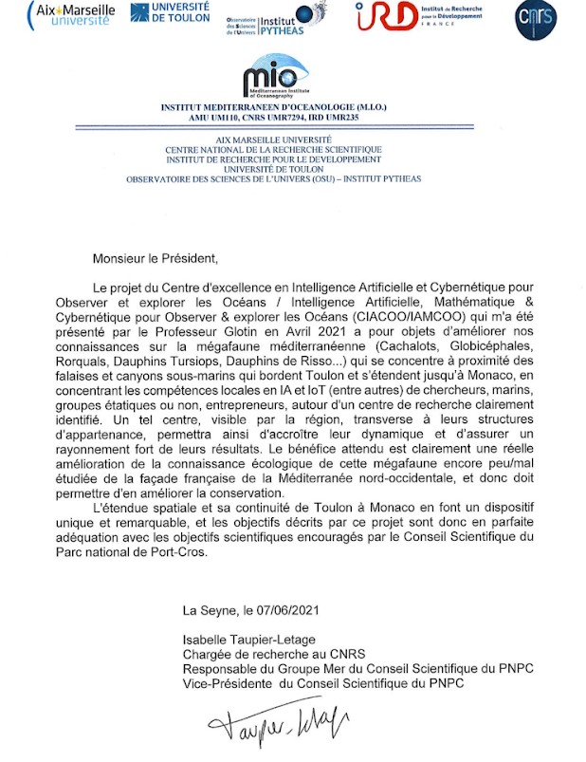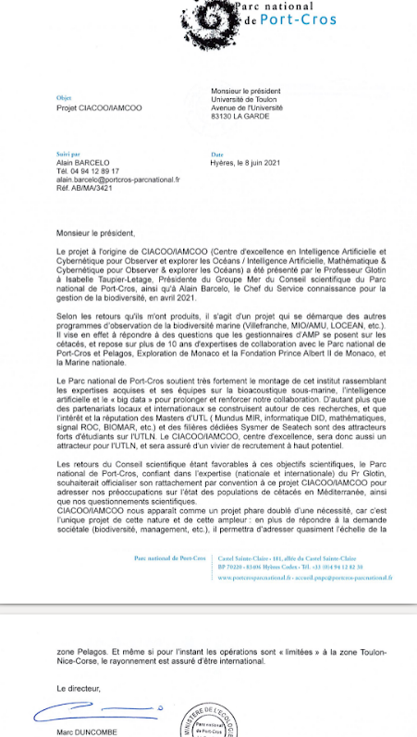

AVIS de la Préfecture Maritime et du MTES
PREMAR :
Très positif, en cours de rédaction

MTES :
en cours, de JANTET Elsa (Adjointe à la cheffe de bureau) - DGALN/DEB/ELM3 <elsa.jantet@developpement-durable.gouv.fr>
Dir Délégué CNRS IM2NP

Le projet de Centre d'Excellence ICoB fédère plusieurs compétences transversales stratégiques sur un même axe fort d'analyse, d’interprétation et de modélisation de milieu très peu connu. Les recherches dans ce domaine sont appuyées par plusieurs ministères (Mer, MTES...) et institutions (Pelagos, PNPC, Explo Monaco, PREMAR, Marine nat.)... Nous savons que l'électronique embarquée et l'IA ULP sont des verrous scientifiques sévères pour ces enjeux (consommation statique, communication, énergie par bits ...), notre activité dans ce domaine sur le site de Toulon est parfaitement en symbiose avec le projet d'excellence ICoB.

Hervé Barthélémy
Dir. Délégué IM2NP, Site de Toulon
UMR CNRS 73 34

7 Programmes Colloques DROIT et BRUIT en mer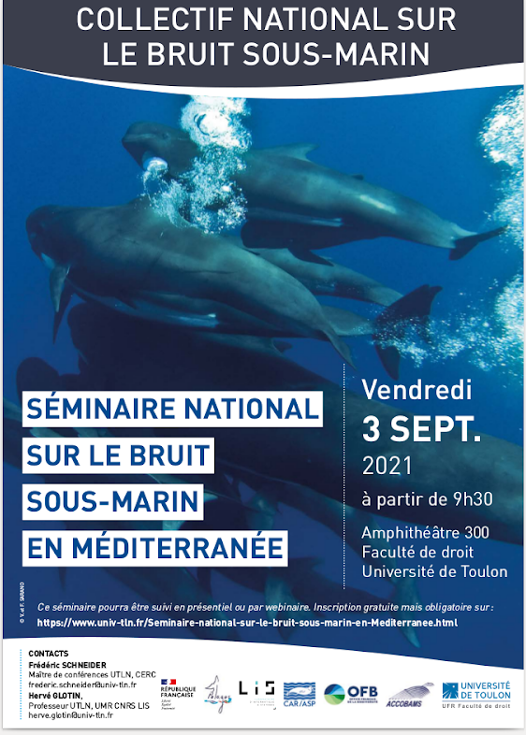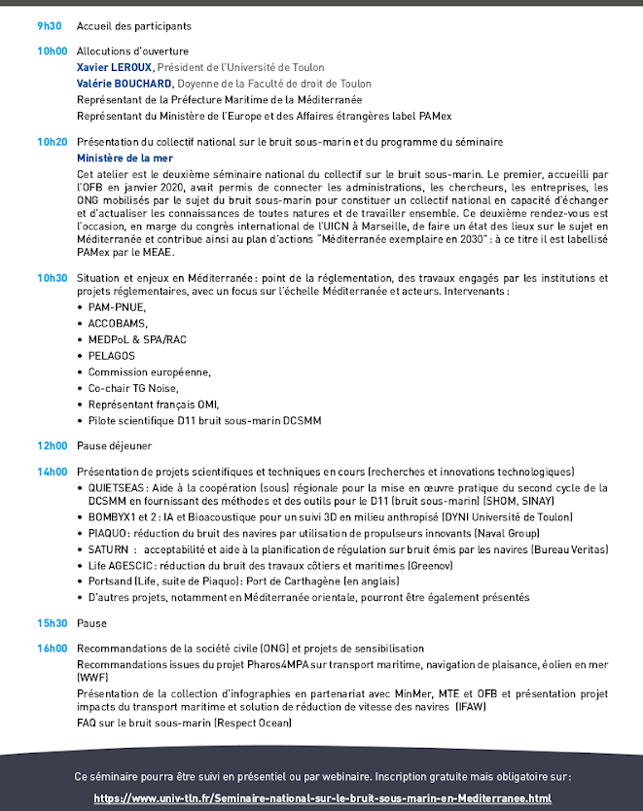

Programme Bruit en Mer UTLN 2021
Colloque international interdisciplinaire Droit & Sciences

Le bruit en mer :
du développement des activités maritimes
à la protection de la faune marine

Vendredi 4 juin 2021

En présentiel pour les intervenants :
Amphithéâtre E. Robinet, Ilot Sainte-Anne, 2 bd St-Anne 83000 Toulon

En ligne pour les autres participants sur inscription (gratuite & obligatoire) : fac.droit@univ-tln.fr

sous la coordination de
Louis Balmond, Professeur émérite UTLN, UMR CNRS CDPC, louis.balmond@univ-tln.fr
Hervé Glotin, Professeur UTLN, UMR CNRS LIS, herve.glotin@univ-tln.fr
Frédéric Schneider, Maître de conférences UTLN, CERC, frederic.schneider@univ-tln.fr

avec les soutiens de la Marine nationale, des pôles INPS et MEDD de l’UTLN et sa Chaire IA ADSIL

Programme

8h30 : Accueil des participants

8h45 : Allocutions d'ouverture
- Xavier LEROUX, Président de l’Université de Toulon
- Laurent REVERSO, Vice-Doyen de la Faculté de droit de Toulon, délégué à la recherche
- Anne-France DIDIER, Conseillère politiques territoriales, Pilote ODD14, DGITM/DAM/Délégation à la mer et au littoral, Ministère de la Mer

9h00 : Introduction générale - Les enjeux de la maîtrise du bruit en mer : le cas de la Méditerranée, Vice-Amiral d’Escadre Laurent ISNARD, Préfet Maritime de la Méditerranée

I. Etat de la recherche sur le bruit en mer et les effets du trafic maritime sur la faune marine

Présidence : Vincent RIGAUD, Directeur du Centre Ifremer Méditerranée

9h15 : Actions de l’Ifremer sur le bruit en mer, Vincent RIGAUD, Ifremer
9h25 : Chaire IA UTLN / BOMBYX GIAS MARITTIMO : mesure du bruit et alerte temps-réel de collision trafic-cétacé, Hervé GLOTIN & DYNI team, Professeur UTLN, UMR CNRS LIS
10h00 : IA embarquée dans la bouée BOMBYX, Valentin GIES, Maître de conférences UTLN, UMR CNRS IM2NP

10h20 : Discussion - Pause

10h40: Bruit de trafic maritime : de la mesure des niveaux rayonnés à la cartographie des effets induits sur la faune marine (cétacés et poissons), Cédric GERVAISE, CHORUS
11h00 : Exploitation du bruit sous-marin au SHOM - Défense et politiques publiques, Florent LE COURTOIS, SHOM
11h20 : Panorama de la réglementation relative au bruit en mer et aux risques de collision entre cétacés et navires, Frédéric SCHNEIDER, Maître de conférences UTLN, CERC

11h40 : Discussion

12h00 : Pause déjeuner

II. Efforts pour réduire le bruit anthropique et limiter les impacts sur la faune marine

Présidence : Jean-Louis FILLON, Délégué Général de l’Institut Français de la Mer

14h00 : Pilotage pour la limitation des impacts des émissions acoustiques en mer, Anne-France DIDIER, Ministère de la Mer
14h20 : Pelagos, bruit et risque de collision avec la mégafaune, Alain BARCELO, Parc national de Port-Cros et Sanctuaire Pelagos
14h40 : Sound in sea and megafauna, Gianni PAVAN, Professeur Université de Pavie, Italie, Expert du GT Bruit ACCOBAMS
15h00 : BOMBYX, première bouée pentaphonique HF à ballast, Olivier PHILIPPE, OSEAN SAS
15h20 : REPCET, retour sur 10 ans de gestion du risque de collisions navires-cétacés, Bertrand GADAIX et Louis DE VRIES, MIRACETI ONG

15h40 : Discussion - Pause

16h00 : Le projet européen Life-PIAQUO, Damien DEMOOR, Naval Group
16h20 : Le bruit en mer, nouvel enjeu environnemental du Préfet maritime, Commissaire général Thierry DUCHESNE, Adjoint au Préfet Maritime de la Méditerranée
16h40 : Transport maritime et environnement au Canada, Michelle T. SANDERS, Directrice Politiques sur l’eau propre, Transports Canada, Gouvernement du Canada (visioconférence)
17h00 : Ressentis d’étudiants de l’École Doctorale Mer & Sciences : Paul BEST, Nicolas THELLIER, Marion POUPARD, Maxence FERRARI, doctorants ou post-docs UTLN

17h10 : Conclusion : Louis BALMOND, Professeur émérite UTLN

17h30 : Fin des travaux de la journée

8. Liste des partenaires avec UTLN en écoute intelligente Marine et Terrestre

* Universitaires / CNRS / INRIA / IRD /... * :
================================

Univ. Jules Verne, UMR LAMFA, bioacoustique IA mer
Mark ASCH <mark.asch@u-picardie.fr>, ANR IA ADSIL,*

UMR LIS, Glotin, Paiement, Paris, Ricard, Razik, Giraudet, Malige, Patris, et al., ANR IA ADSIL, COCHLEA, SYLVANIA, PIA3 PSIBIOM PIA3 TERRAFORMA, ADAPREDAT, FJORD3D, MITI CNRS, projet EU BIODIVERSA, FEDER GIAS1, 2, Projet Pays Bleu, veille avifaune Caraïbe,*

UMR IM2NP, Gies Barthelemy, ANR ULPCOCHLEA, SYLVANIA, SEAWHOLE, PIA3 TERRAFORMA, ADAPREDAT,*

EA COSMER, Hugel et al., ANR SEAWHOLE (*)

CERC, Schneider, projet animation avec MTES

Univ. Sorbonne, UMR Inst. JR d'Alembert, bioacoustique IA mer
<olivier.adam@sorbonne-universite.fr>, dépot projet PPR

Univ. Montpellier, UMR MARBEC (Univ Montpellier, IRD, IFREMER, CNRS), bioacoustique IA mer
Bastien Merigot <bastien.merigot@umontpellier.fr>, codir thèse

INRIA Montpellier, acoustique IA, mer
<antoine.liutkus@inria.fr>, ANR IA ADSIL

AMU, UMR LMA, acoustique IA, mer
cristini@lma.cnrs-mrs.fr, ANR IA ADSIL, *

IRD Avignon, bioacoustique, terre
Institut Méditerranéen de Biodiversité et d'Ecologie marine et continentale
amandine.gasc@ird.fr, Ecoute des Maures

MNHN Paris, UMR ISYEB, bioacoustique IA terre (anthropisation, changement climatique, écologie des communautés des milieux terrestres et eaux douces
Romain GARROUSTE <romain.garrouste@mnhn.fr>, Ecoute des Maures et collaboration Reserve Nationale Naturelle de la plaine des maures et Réserves RBI du Var (ONF), Parc de Port Cros

Univ Lyon, UMR LEHNA, bioacoustique, terre
<thierry.lengagne@univ-lyon1.fr>, ANR SYLVANIA,*

UMR CRISTAL, bioacoustique IA
P. Devienne, ANR ULP COCHLEA

* Universitaires internationaux * :
========================

Univ Pavia, IT, CIBRA, bioacoustique, terre mer
Gianni Pavan <gianni.pavan@unipv.it>, projet EU BIODIVERSA,*

Univ SanDiego, USA, bioacoustique IA, terre mer
marie.roch@sdsu.edu

Ministère des forêts Québec, bioacoustique terre
Anouk.Simard@mffp.gouv.qc.ca, Projet Pays Bleu

Univ. Rimouski, Canada, bioacoustique IA mer
Yvan.Simard@dfo-mpo.gc.ca,

Univ. Santiago, COPAS Sur-Austral & Visiting Professor, University of Concepción, Chile
CEAZA Research Center, Chili, bioacoustique mer
Susannah Buchan <sjbuchan@gmail.com>, FJORD3D REJES, MITI (*)

Centre Antarctique Chili, bioacoustique mer
Madeleine Hamame Villablanca <mhamame@ciep.cl>, FJORD3D MITI

Univ Norte Brazil, Centre boacoustique IA terre mer
<sousalima.renata@gmail.com>, thèse CIFRE

Univ Tokyo, bioacoustique IA terre
"Hill H. KOBAYASHI" <kobayashi@ds.itc.u-tokyo.ac.jp>, convention avec UTLN, veille Fukushima par biacoustique,*

AWI, centre polaire Allemand, bioacoustique IA mer
elena.schall@awi.de, projet DE FR ANR, *

Univ Acorez, Portugal, bioacoustique mer
Cláudia Inês Botelho de Oliveira <claudia.ib.oliveira@uac.pt>, LIFE BIODIVERSA,*

Bermude gov, bioacoustique mer
"Manuel, Sarah" <smanuel@gov.bm>, "Outerbridge, Mark" <mouterbridge@gov.bm>, FEDER CARIMAM OFB

Univ tech. Jamaica, bioacoustique mer
Christine O'Sullivan <christine.utech@gmail.com>, FEDER CARIMAM OFB

Stenapa env., bioacoustique mer
Marit Pistor <marit.pistor@statiapark.org>, FEDER CARIMAM OFB

Reserve naturelle St-Martin, bioacoustique mer
Julien Chalifour <science@rnsm.org>, FEDER CARIMAM OFB

Ocean Network Canada, bioacoustique IA mer
Kim Juniper, long terme collaboration

* ONG * :
=======

Bonaire, bioacoustique mer
nature@stinapa.org, FEDER CARIMAM OFB

Bahamas Whales, bioacoustique mer
cdunn@bahamaswhales.org, FEDER CARIMAM OFB,*

Guadeloupe, bioacoustique mer
Laurent Bouveret <laurent.bouveret@gmail.com>, BREACH ANTILLES cathy LACOURBAS <c.lacourbas@orange.fr>, FEDER CARIMAM OFB

Guyanne, bioacoustique mer terre
Amandine Bordin <amandine.bordin@gepog.org>, FEDER CARIMAM OFB

Longitude 181, bioacoustique mer
saranofrancois@gmail.com, veronique.sarano@longitude181.org, Mission Sphyrna Odyssée FPA2 Explo Monaco, Mission ECHO, FJORD3D ADAPPREDAT, *

OFB caraibes, bioacoustique mer terre
"Sébastien Gréaux, Agence Environnement, sebastien.greaux@agence-environnement.fr>,
Jonas HOCHART <jonas.hochart@agence-environnement.fr>, FEDER CARIMAM OFB *

* Institutions * :
==========
Ministère de la Mer, bioacoustique mer
Didier Anne France, Clairaux, conseiller scientifique de la ministre, legislations anthropophonie

PELAGOS, bioacoustique mer
costanzafavilli@pelagos-sanctuary.org, FEDER GIAS, BIODIVERSA …

OFB bioacoustique terre
VILLERS Alexandre <alexandre.villers@ofb.gouv.fr>, veille avifaune caraïbe, *

Conservatoire du littoral, bioacoustique terre
Marie-claude SERRA <mcserra@var.fr>, Dominique GUICHETEAU <dguicheteau@var.fr>, Ecoute des Maures

Parc Cap Corse, bioacoustique mer terre
nicolas.tomasi@ofb.gouv.fr, GIAS FEDER, *

Off. Env. Corse, bioacoustique mer terre
Jean-Michel Culioli <culioli@oec.fr>, BOMBYX2

Parc National Port-Cros, bioacoustique mer terre
PEIRACHE Marion <marion.peirache@portcros-parcnational.fr>, Alain BARCELO <alain.barcelo@portcros-parcnational.fr>, BOMBYX1/2, GIAS, *

PREMAR, préfecture Maritime, GIAS FEDER, BOMBYX1,2… (*)

* PME * (non exhautif)
=================

AKVAPLAN, Norvège, bioacoustique IA mer
Luca Tassara <lut@akvaplan.niva.no>, Lionel Camus <lca@akvaplan.niva.no>, ADAPREDAT MITI CNRS, FJORD3D, BIODIVERSA *
Sofia Aniceto <ana.s.aniceto@uit.no>, FJORD3D, LIFE BIODIVERSA,*

NORTEK med, Toulon, bioacoustique IA mer
estelle.richard@nortekgroup.com

OSEAN, Toulon, bioacoustique IA mer
Nathan Jallet - nathan.jallet@osean.fr
olivier.philippe@osean.fr, GIAS FEDER, *

GreenPraxis, Marseille, bioacoustique IA terre
Jerome Di Giovanni <Jerome@greenpraxis.com>, Martin Guillaume <martin@greenpraxis.com>, CIFRE, *

Aquasearch, Martinique, bioacoustique IA mer
Benjamin de Montgolfier <b.montgolfier@aquasearch.fr>, FORTdeFRANCE

SEAPROVEN, Laval, bioacoustique IA mer
<at@seaproven.com>, Missions Sphyrna *

… ENGIE, Total Energie renouvellable, Eolbio, Marepolis…
894

9. Partner Man month per task (Internal and External Partners)
see core

10. Budget template for the submission

The pre-budget shall be presented, precised into this GXLS =

https://docs.google.com/spreadsheets/d/1vOhzk77A8yEW6HJSlXHsLj7ZnW7agdizb0TjAqCrlHg/edit?usp=sharing

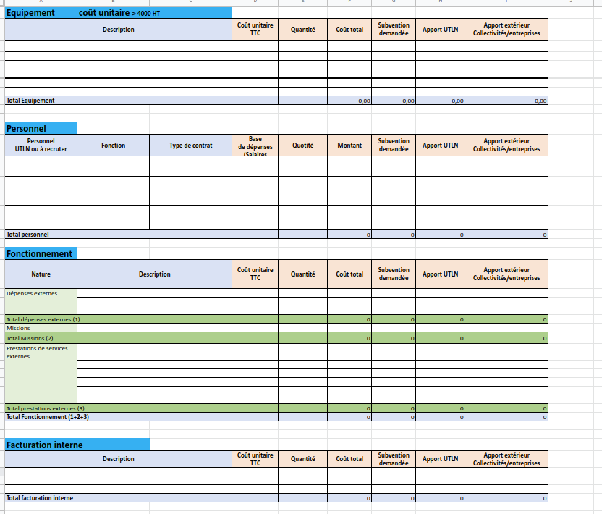
Fig : illustration of the budget to fill in the GXLS

https://anr.fr/fr/detail/call/chaires-de-recherche-et-denseignement-en-intelligence-artificielle/#
Le CNRS, DS IN2SI, a offert en 2021 à ces recherches UTLN 1 an d'ingénieur à Saclay sur J. Zay.
http://sabiod.lis-lab.fr/pub/QHB.pdf

